‘The Story of a National Crime’ | The Tyee and Speech by MP Mumilaaq Qaqqaq
For 15 years, Canada’s first chief officer of medical health repeatedly warned his superiors that the country’s disease-riddled residential schools had become glorified tuberculosis death camps. He courageously pressed for reforms.
But Bryce’s superiors didn’t listen. They didn’t want to know the truth, and made the physician’s job impossible as only bureaucrats can do.
And so, when Bryce left the government and was no longer oath-bound to secrecy, he wrote a 24-page exposé on the accelerated extinction of Indigenous people willfully being perpetrated in Canada’s residential schools. You can read it here. The story of a national crime
Bryce titled his book The Story of a National Crime. The year was 1922.
-------------------------------------------------------------------------------

A century ago, Dr. Peter Bryce demonstrated that residential schools were designed to kill. Canada’s government ignored him.
Andrew Nikiforuk 2 Jun 2021 | TheTyee.ca
Tyee contributing editor Andrew Nikiforuk is an award-winning journalist whose books and articles focus on epidemics, the energy industry, nature and more.

‘The Story of a National Crime’

A century ago, Dr. Peter Bryce demonstrated that residential schools were designed to kill. Canada’s government ignored him.
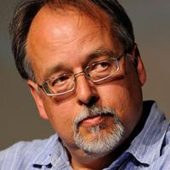
Andrew Nikiforuk 2 Jun 2021 | TheTyee.ca
Tyee contributing editor Andrew Nikiforuk is an award-winning journalist whose books and articles focus on epidemics, the energy industry, nature and more.

This is how many residential schools were in Ontario and where they were located (blogto.com)
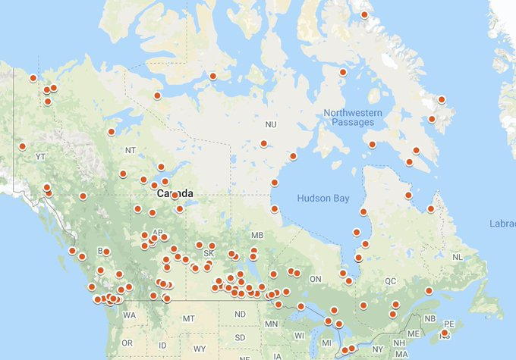

Mumilaaq Qaqqaq on Twitter: "This is a map of every residential "school" site in Canada. Every dot is a crime scene. Only a few have been investigated so far. Canada, do not get used to these numbers. Do not let them become statistics. Put yourselves in the shoes of these children in the ground. https://t.co/5XJS1w1ka2" / Twitter

MP Mumilaaq Qaqqaq:
I came to Parliament seeking help for Indigenous people, but no one cares enough to act. I’m glad people are finally listening to what I’ve been saying over and over in my time in federal politics. https://www.thestar.com/politics/political-opinion/2021/06/18/i-came-to-parliament-seeking-help-for-indigenous-people-but-no-one-cares-enough-to-act.html “

Foster care is modern-day residential school system: Inuk MP Mumilaaq QaqqaqTW
By Teresa WrightThe Canadian Press
Fri., June 4, 2021

https://www.thestar.com/politics/2021/06/04/foster-care-is-modern-day-residential-school-system-inuit-mp-mumilaaq-qaqqaq.html

CBC News Alerts on Twitter: "Nunavut NDP MP Mumilaaq ...
https://twitter.com › cbcalerts › status

Oct. 23, 2020 — Nunavut NDP MP Mumilaaq Qaqqaq says she is stepping aside for at least 8 weeks to heal from what she describes as 'personal health ...
Tamara said: I want to I urge you to watch the 8-minute farewell speech by Mumilaaq Qaqqaq, the 27-year old NDP MP for Nunavut, who is stepping away from politics and will no longer remain in the House of Commons: https://www.cbc.ca/news/politics/parliament-farewell-speeches-1.6067283
Please see her report on the “deplorable housing conditions” in Nunavut: https://www.aptnnews.ca/wp-content/uploads/2021/03/Qaqqaq.HousingReport.2021-1.pdf and please see the news report here: https://nunatsiaq.com/stories/article/nunavut-mp-releases-report-on-territorys-housing-crisis/ and https://www.cbc.ca/news/canada/north/nunavut-mp-housing-report-decries-living-conditions-1.5965339
Her tour of the housing crisis and poverty in her territory last year led her to take a mental health leave and influenced her decision to quit politics.

