America’s Suburbs Are Breeding Grounds for Fascism
Story by P.E. Moskowitz • June 7, 2023
America’s Suburbs Are Breeding Grounds for Fascism (msn.com)

Hate against trans people is rising, but the suburbs are what gives
this hate its fervor and popularity.

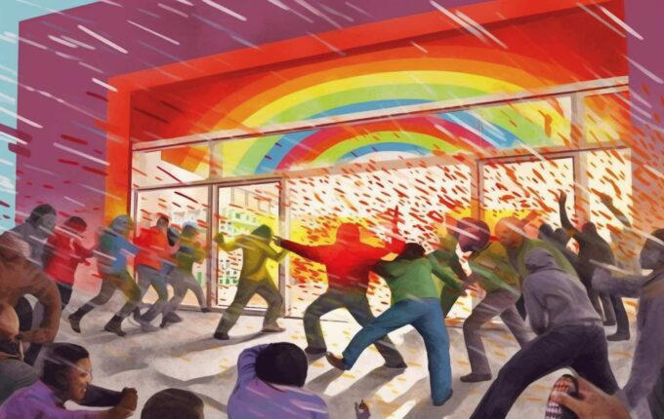
The Target store closest to where I sit is in Torrington, Conn. It’s next to a Home Depot, a Wendy’s, a Walgreens, a Walmart, a Chipotle. Driving is the only option here, unless you’re willing to take the one available bus from downtown and then walk along one of two large highways that bisect the area. If you drive down a few miles, roads without sidewalks appear, on which sit houses for sale—four bedrooms, new construction, two-car garages, and gray exteriors.
Places like this are the most common form of American life—as of 2017, 52 percent of Americans lived in suburbs. There are of course differences between, say, a suburb in Connecticut and a suburb in Texas. But they’re all variations on a formula, and lives lived in suburban areas tend to revolve around the same kinds of places, and the same kinds of ideology.
And so it makes sense that these are now the places where fascism grows; that’s what these places were designed for. The suburbs were invented as a reactionary tool against the women’s liberation and civil rights movements. The US government, in concert with banks, landowners, and home builders, created a way to try and stop all that, by separating people into single homes, removing public spaces, and ensuring that every neighborhood was segregated via redlining. The suburbs would keep white women at home, and would keep white men at work to afford that home. These were explicit goals of the designers: “No man who owns his house and lot can be a Communist,” said the creator of Levittown, the model suburb. “He has too much to do.”
The reason Target has become the locus of today’s particular right-wing backlash is the same reason countless viral TikToks attempt to convince women that they’re at risk of being kidnapped every time they’re in a parking lot. It’s the reason why true crime is one of the most popular podcast genres in America, and why many refuse to travel without a gun by their side and shoot people if they set foot on their driveway.
Hate against trans people is rising, but the suburbs are what give this hate its fervor and popularity. A million Torringtons, a million of the same location in different locations, in which any difference, or anything out of place or spontaneous, is perceived as a threat.
It is of course true that these mass hysterias are part of an organized right-wing movement that is attacking human rights across the country—through legislation banning abortion, gender-affirming care, and books, and making it illegal for educators to teach American history accurately. But the shape this movement has taken is not coincidental; it is in fact the product of the unique shape of public life in America, or lack thereof. Suburbanites do not have town squares in which to protest. They do not have streets to march down. Target has become the closest thing many have to a public forum.
We often hear that urban areas are more liberal and suburban ones more conservative, and we’re often told that this is because of race. That may be partly true, though cities are whiter than ever and suburbs more diverse than ever. Instead, it may be that suburbanism itself, as an ideology, breeds reactionary thinking and turns Americans into people constantly scared of a Big Bad Other.
The suburban doctrine dictates that public space be limited, and conflict-free where it exists; that private space serve only as a place of commodity exchange; that surveillance, hyper-individualism, and constant vigilance are good and normal and keep people safe. It is an ideology that extends beyond the suburbs; it infects everything. Even cities, as Sarah Schulman writes in The Gentrification of the Mind, have become places where people expect convenience and calmness over culture and community. What is a life of living in a surveilled and amenity-filled high-rise and ordering all your food and objects from the Internet to your door if not a suburban life? To make matters worse, the people who have adopted this mindset do not see it as an ideology, but as the normal and right state of the world; they, as Schulman writes, “look in the mirror and think it’s a window.” So when anything, even a gay T-shirt, disrupts their view, they become scared.
The anti-trans panic at the center of the Target controversy says something dark about American politics, but it says something even darker about the American landscape, about the places and ways we choose to live. Without a massive reorganization of American life—away from privatization, car-centrism, and hyper-individualism—it’s likely the suburban ideology will remain popular, and even grow.

