Global
Canada Is Taking Trump Seriously and Personally
Sometimes sporting events really are bigger than the game itself.
By Ken Dryden
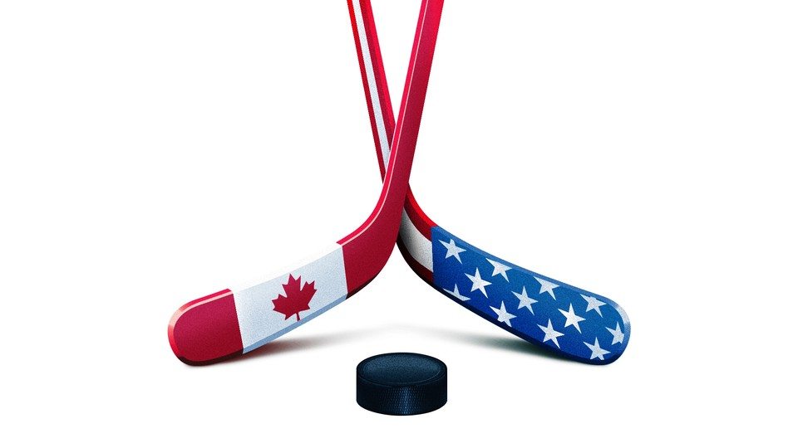
Illustration by The Atlantic. Source: Shutterstock.
February 23, 2025, 5:03 PM ET
Last Saturday, I was in Montreal for the Canada-U.S. hockey game in the 4 Nations Cup. I knew I needed to be there. A few nights later, I was at home in front of our TV for the final game, which Canada won 3–2 in overtime. I watched every moment, from before the game began to after it ended. I almost never do that. Those games, I knew, were going to say something—about Canadian players, about Canadian fans, about Canada. Maybe something about the United States too. I didn’t know what.
Sports can tell big stories. I was one of two goalies for Canada in the Canada–Soviet Union series in 1972, the first international best-against-best hockey series. Until that moment, professional players from the NHL were not eligible to compete in the amateurs-only Olympic Games or World Championships. Canada was where hockey originated, where all of the best players in the world were born and developed. To the total annoyance of Canadians, year after year the Soviet Union, not Canada, became known as “World Champions.”
The 1972 showdown was eight games: four in Canada, four in Moscow. Everyone—the Canadian players and fans, even the Soviet players and fans and the experts from both countries—knew that Canada would win decisively, likely all eight games and by big scores.
In Game 1 in Montreal, the Soviets won, 7–3. Imagine the reaction all across Canada. Then multiply that by 10.
Instantly, the stakes changed. Something deeper than hockey pride was on the line. We were the best in the world when it came to hockey; the rest of the world didn’t think about Canada that way when it came to many other things. Now we had lost. What did that say about us? About Canada? About Canadians? The next seven games would decide. These were the stakes.
We left Canada trailing two games to one, with one game tied. We lost the first game in Moscow. The series was all but over. Then we won the next two games, leaving it to one final game. In 1972, not many North Americans traveled to Europe; almost none went to Moscow. Three thousand Canadians were in that arena. They were there because, somehow, they knew they had to be there. For the last game, on a Thursday, played entirely during work and school hours all across the country, 16 million out of Canada’s population of 22 million people watched. Behind two goals to start the third period, we tied the game, then won it, and the series, with 34 seconds remaining. I felt immense excitement. I felt even more immense relief. In that series, Canadians discovered a depth of feeling for their country that they hadn’t known was there.
In 1980, I was the other person in the Olympics booth in Lake Placid, New York, when the U.S. beat the Soviets and won the gold medal. (When Al Michaels said, “Do you believe in miracles? Yes!,” I said, “Unbelievable.”) At the beginning of the Olympics, for the U.S., there were no stakes. The team was made up almost entirely of college kids. The Soviets, at the time, were the best team in the world. Even after the U.S. team won some early games, their players seemed on a roll to enjoy, not to be taken seriously. Then they beat the Soviets and two days later defeated Finland to win the gold.
This was not a good time for the U.S. in the world. Among other problems and conflicts, Iran was holding 52 Americans hostage in Tehran. Weeks passed. The U.S. seemed powerless to get them back. Unbeknownst to all but a few, six of the hostages—all American diplomats—had escaped and were being hidden in the Canadian Embassy. The Canadians sheltered the diplomats for months, and eventually helped them escape. The news that the diplomats had made it safely out of Iran came just before the Lake Placid games began. Everywhere I went around the village, Americans came up to me and said, “Thank you, Canada,” as if they were otherwise friendless in the world.
In 1980, hockey was not a major sport in the U.S., and so Americans had no expectation or even hope of winning against the Soviets. What they did have at stake in 1980 was the Cold War. That they had to win. The hockey team’s victory in Lake Placid felt like part of this bigger fight. It fit the story Americans wanted to tell about themselves. And although hockey was a fairly minor sport, 45 years later, for many Americans, the “Miracle on Ice” remains their favorite patriotic sports moment.
Now to today. Now to the 4 Nations Cup. Being Canadian these past few months hasn’t been a lot of fun. The threat and now the coming reality of high tariffs on Canadian goods exported to the U.S.—and the disruptions and dislocations, known and unknown, that these tariffs will cause—is never out of mind. Even more difficult in the day-to-day is Donald Trump’s relentless and insulting commentary.
Canada as the U.S.’s “51st state”; Prime Minister Justin Trudeau as “Governor Trudeau”; the U.S. using “economic force” to annex Canada, its nearest ally and inescapable geographical fact of life. It’s the kind of trolling that Trump does to everyone, to every country, whenever he wants to, because as president of the most powerful nation on Earth, he knows he can. He loves to watch the weak wobble and cringe, and those who think they’re strong discover they’re not.
Na na na na na. It sets a tone. It lets everyone know who’s boss. It’s what he’d done all his life in business. And although at a boardroom table he wasn’t always the guy with the deepest pockets, in the Oval Office of the United States of America, he knows he is. Being Donald Trump got him elected, but being president is what allows him to be Donald Trump. On November 5, nobody had as much at stake in the election’s result as he did. He needed to win to hold the world’s highest office, to avoid lawsuits and prison time. He needed to win to be him.
It's been amazing to watch world leaders of proud, historically significant countries, kings in their own domain, suck up to Donald Trump, to see billionaires and business titans, who know how the game is played—cater to political authority in public, play hardball in private—who reside proudly and smugly above and beyond politics, fold like a cheap suit. And later, when they do respond, because prime ministers, presidents, and CEOs eventually have to say something, their words sound so lame. “There’s not a snowball’s chance in hell that Canada would become part of the United States,” Trudeau said. By answering at all, you end up making any slur sound slightly, disturbingly legitimate, and you make yourself look weak.
How would Americans react if a president or prime minister of another country said the same about their president? That he’s crooked, crazy, a lunatic, a loser? That he’s the worst president in the history of the world? That their country is just another failed empire in its final death throes? That both president and country are a disgrace and everyone knows it? Probably not well.
But what do you do? What do the decision makers in other countries do? What do average Canadians, average Panamanians and Danes, what do ordinary people anywhere do? That’s why I needed to be at that game in Montreal.
Thirty years earlier, in 1995, on the weekend before Quebec’s second referendum on independence, my family and I went to Montreal to wander the city, to try to sense what Quebeckers were feeling, but mostly just to be there. On a Saturday night, we went to a Montreal Canadiens game. We wanted to be there for the singing of “O Canada.” The next day, a reporter for an English-language newspaper wrote that it was the loudest he had ever heard the anthem sung at a game. What he didn’t notice was that 10,000 people sang their hearts out, and 10,000 people were silent.
Last Saturday in Montreal, the arena was filled with fans in red-and-white Canada jerseys. The NHL and the NHL Players Association, which had organized the event, did what organizers do. They asked the fans to be respectful of both teams during the anthems. The fans decided not to be managed. They booed “The Star-Spangled Banner” loudly. They were not booing the American players. They were booing Donald Trump. Why shouldn’t he know how they felt? Why shouldn’t Americans know? How else would they know?
Five nights later in Boston, at the final game, the fans booed “O Canada,” but not very loudly.
The game was a classic. The two best teams in the world: Canada, the heart and soul, conscience and bedrock of the game; the U.S., in its development and growth, the great story in hockey in the past 30 years. Both teams played as well as they’d ever played. Their great stars played like great stars; some other players discovered in themselves something even they didn’t know was there. The U.S. could’ve won. The team was good enough to win. Canada won because of Connor McDavid, Nathan MacKinnon, and Sidney Crosby—and for the same reason Canada won against the Soviets in 1972.
Everybody, every country, has something inside them that is fundamental. That matters so much that it’s not negotiable. That’s deeply, deeply personal. Something that, if threatened, you’d do anything to protect, and keep on doing it until it’s done, even if it seems to others to make no sense. Even if it seems stupid. This is how wars start.
For Panama, some things are fundamental. For Denmark, China, Russia, Germany, Ukraine, Canada—for everyone—it’s the same. And when you get pushed too much, too far, you rediscover what that fundamental is. Poke the bear and you find out there’s more in the bear than you know, than even the bear knows.
For Canada and these other countries, you don’t poke back against Donald Trump. You don’t troll a troll. You look into yourselves and find again what makes you special, why you matter, to yourselves, to the world, and knowing that, knowing that that is you, with that as your pride and backbone, you fight back.
The U.S. has its own fights. It faces these same questions. What is fundamental to America? “Greatness”? Maybe. But greatness depends on the needs of a country and the needs of the world at a particular moment and time, and being great in the ways that are needed. These next four years will not be easy for anyone—and they will be perhaps especially difficult for the United States.
As for the 51st state crap, knock it off. It’s beneath you.
For Donald Trump, everything is a transaction. You look to make a deal, you push and shove, scratch and claw—you do whatever it takes. And if that doesn’t work, you do some more, until at some point you walk away and make another deal. It’s just business.
Only some things aren’t business. Every so often, Canadians are defiantly not-American. They will need to be much more than that in the next four years. Canadians will need to be defiantly Canadian. Canada won in 1972 and again last week because winning was about more than business. It was personal.

