People Progress
Sunday Community

September 18, 2022 25th Sunday in Ordinary Time E. R. Whelan

Virtual Liturgy at 11 AM on Zoom.

Thank you, Fr. Jack Costello for celebrating with us.

Reflection is below.

Readings:
Today: Amos 8:4-7 Psalm 113 I Timothy 2:1-7 Luke 16:1-13
Sept 25: Amos 6:1, 4-7 Psalm 146 I Timothy 6.11-16 Luke 16:19-31

Liturgy Schedule
Date Planner Priest
Today Lee Piepgrass Fr. Jack Costello
Sep 25 Lindsay & Bill Watson Fr. Paul McAuley
Oct 2 Greg Gillis Fr. Ron MacDonell
Oct 9 Mary Lou Halferty Fr. Paul McAuley
Oct 16 Art Blomme Fr Jack Costello
Oct 23 Mary & John MacMillan Fr. Ron MacDonell
Oct 30 Sheila & Rob Barrett Fr. Ron MacDonell

Note: All liturgies for Sep, Oct, and Nov 13 will be on Zoom.
See Brian's Liturgy notes below. He and Bill are working on in-person liturgies for Nov 6
and Nov 20 (Zoom as well)

This schedule, as always, is flexible. Planners, feel free to switch if you cannot do a liturgy on the scheduled date. Just be sure to tell the People Progress Reporter, so that we all know.

Reflection:
Introduction: The gospel this week really had me buffaloed, so I turned to my friend Millie Dosh who, when she was in the Poor Clare nun business, spent a fair bit of time studying theology.

And she did not disappoint!!! I decided to share it with you all just as she sent it to me. As some of you know, Bernard Lonergan was one of my husband Don’s favourites. I don’t know when it was published. Personally, I think he's reaching. :) Lee

People Progress Schedule
September: Elizabeth Whelan
October: John MacMillan
November: Maryanne S-J and Roberto J
December: Mary Lou Jorgensen-Bacher

Announcements:

Liturgy Planning for the Fall of 2022: Brian Halferty
As has been announced a couple of times in verbal announcements, a few members of the Sunday Community have been putting their heads together to plan for our Sunday liturgies for future months. Also, the results of the Community Survey are still coming in, and we are looking carefully at those. Here’s how things are looking so far:
- Our schedule of weekly Masses for 2022-23 will begin on Sunday, September 11, 2022, via ZOOM. We will continue with weekly Masses on Zoom through September, and October and beyond.
- We are tentatively planning to schedule two in-person Masses at Msgr Fraser Annex as follows:
- Sunday November 6, 2022
- Sunday November 20, 2022
Our plan is that these Masses will also be available via Zoom, making them “hybrid” events in which people can participate in person or online.
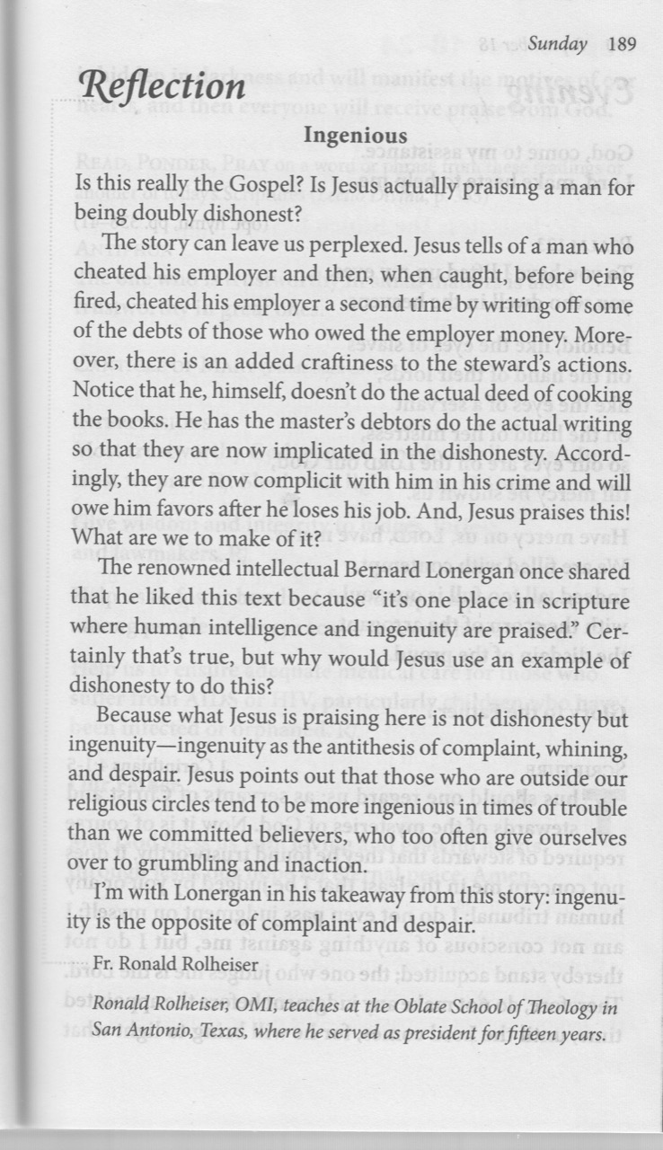
- Following those two “hybrid” liturgies, we will evaluate the effectiveness of doing it that way, and we may then schedule regular “hybrid” liturgies once or twice a month through the rest of the year, while continuing with the Zoom liturgies on all other Sundays.
- Evaluation of the “hybrid” liturgies will especially focus on how well the technology works for us. We will be trying out a device called the “Meeting Owl 3”. This device has a purchase price of $1,399.00 CD, plus tax. If we try it and find it unsatisfactory, we can return it if we do so within 30 days.

Further information will be available as we go along. Please feel free to ask any questions you have or to make any suggestions you wish to make. You can send any of this to Brian, at bhalferty@yahoo.ca

- Egg cartons: Please continue to save your empty egg cartons for Elizabeth Stocking. She welcomes cartons and flats; you can deliver them to Elizabeth Whelan, and Elizabeth Stocking will pick them up. She thanks everyone who has contributed them, and has shared the recent 'collection' with two neighbouring farmers in need.

• Thank You to everyone who came to the Summer Potluck Gatherings. It was wonderful to
get together and share conversation, food, and hugs. People asked about the next one....

September Birthdays: Happy Birthday to
1. Julia Gorman
3. David Watson
11. Sean Olsthoorn
11. Rachel Smiley
16. Elizabeth Whelan
17. Matteo Calla
17. Michel Quintas
21. Bill Watson
23. Denise Colterman-Fox
26. Mary MacMillan
28. Catherine Cavanagh

Re-printed weekly for reference:
Duties of liturgy planners for virtual masses:

Early in the week before the liturgy:
- Call or email the priest to confirm Sunday’s liturgy (contact info will be provided).
- Prepare or find a Reflection and send it to the People Progress reporter by Thursday. Please notify the People Progress reporter early in the week if you cannot do a Reflection.
- Select readers for the 1st and 2nd readings; check with Brian Halferty regarding the psalm.

On the Sunday of the virtual mass:
- Greet the group (Ask newcomers to introduce themselves)
- Give a brief introduction to the liturgy.
- Read your passage /be prepared to do a reading (if a volunteer is unable to log-in)
- Thank everyone who ‘attended’ and those who helped (at Announcements)

