People Progress
Sunday Community

September 25, 2022 26th Sunday in Ordinary Time E. R. Whelan

Virtual Liturgy at 11 AM on Zoom.

Thank you, Fr. Paul McAuley for celebrating with us.

Reflection: Bill and Lindsay

We recently cleaned out our basement which held 30+ years of toys, books, electronic equipment, and sundry other items. We felt good about being able to donate a lot of the items to the local Thrift depot so that our still useful things could help others.

Reflecting on that process, we realized how much ‘stuff ‘ we had accumulated over the years. How did it happen and how good it feels to donate the items to someone who might be able to use them now.

As the reflection from “Living with Christ” says, “We are often looking for more and better things, and have an unhealthy obsession with getting ahead and getting richer in the material sense. We can desire and enjoy these blessings, but did we share them and love others?”
Today’s Gospel relates the parable of the rich man and Lazarus who both die. Lazarus is carried to heaven with the angels, and the rich man to Hades where he ‘agonizes in the flames’. He then begs God to warn his 5 brothers.

Shane Claiborne (Center for Action and Contemplation) expresses the following.
“I think this parable shows us we have a pattern in our culture that teaches us to insulate ourselves from suffering, to build up gates and walls and border fences that separate us from those who are suffering right outside of our comfort. But we come to find out that not only are we locking the suffering out, but we’re locking ourselves in—to a life that’s incredibly lonely. Those patterns rob us of life and community.
St. John Chrysostom pointed out that Lazarus is the only person named in the parables of Jesus. His name means “the one that God heard and rescued.” The rich man is not given a name. He cries out to Father Abraham, so it sounds like he was a religious man, but he had locked the poor out of his life. I think the invitation is to rewrite the end of the story. We have an invitation to tear down the walls, to bust through the fences, and to get to know the names and the faces of those who are suffering outside of our comfort.”
On this World Day of Migrants and Refugees we should also consider the many ways we have gifts to share such as making time for others, listening to them, showing compassion for and helping others. Let us choose the gift of life in the many ways we are able.

Readings:
Today: Amos 6:1, 4-7 Psalm 146 I Timothy 6.11-16 Luke 16:19-31
Oct 2: Habakkuk 1:2-3; 2:2-4 Psalm 95 2 Timothy 1.6-8, 13-14 Luke 17.5-10
Liturgy Schedule
Date Planner Priest
Today: Lindsay & Bill Watson Fr. Paul McAuley
Oct 2 Greg Gillis Fr. Ron MacDonell
Oct 9 Mary Lou Halferty Fr. Paul McAuley
Oct 16 Art Blomme Fr Jack Costello
Oct 23 Mary & John MacMillan Fr. Ron MacDonell
Oct 30 Sheila & Rob Barrett Fr. Ron MacDonell

Note: All liturgies for Sep, Oct, and Nov 13 will be on Zoom.
See Brian's Liturgy notes below. He and Bill are working on in-person liturgies for Nov 6
and Nov 20 (Zoom as well)

This schedule, as always, is flexible. Planners, feel free to switch if you cannot do a liturgy on the scheduled date. Just be sure to tell the People Progress Reporter, so that we all know.

People Progress Schedule
September: Elizabeth Whelan
October: John MacMillan
November: Maryanne S-J and Roberto J
December: Mary Lou Jorgensen-Bacher

Announcements:
Liturgy Planning for the Fall of 2022: Brian Halferty
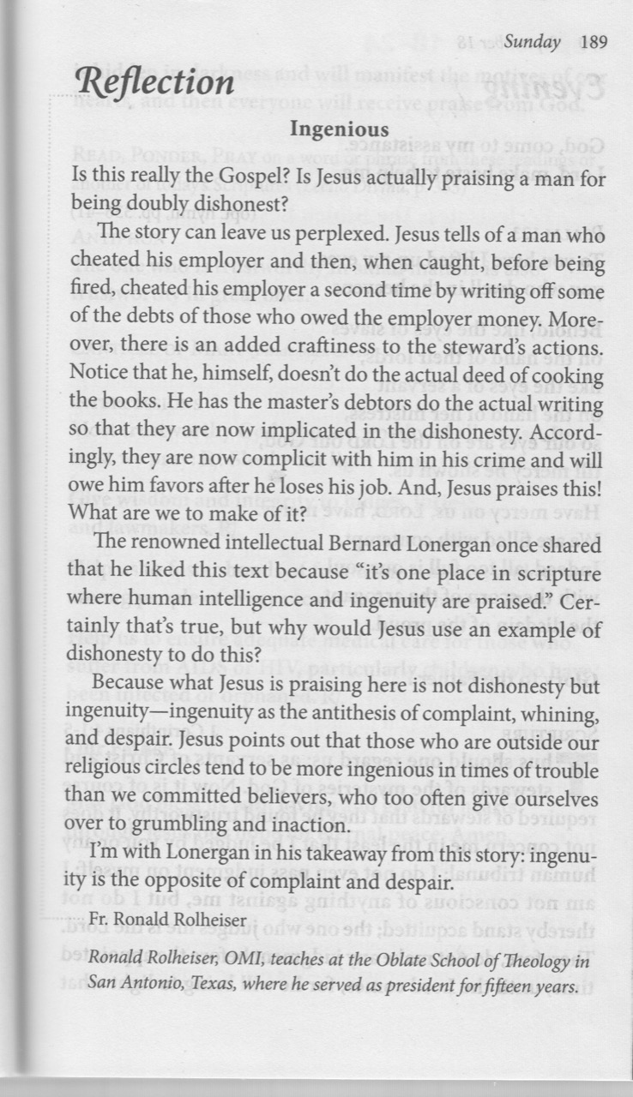
As has been announced a couple of times in verbal announcements, a few members of the Sunday Community have been putting their heads together to plan for our Sunday liturgies for future months. Also, the results of the Community Survey are still coming in, and we are looking carefully at those. Here’s how things are looking so far:
- Our schedule of weekly Masses for 2022-23 will begin on Sunday, September 11, 2022, via ZOOM. We will continue with weekly Masses on Zoom through September, and October and beyond.
- We are tentatively planning to schedule two in-person Masses at Msgr Fraser Annex as follows:
- Sunday November 6, 2022
- Sunday November 20, 2022
Our plan is that these Masses will also be available via Zoom, making them “hybrid” events in which people can participate in person or online.
- Following those two “hybrid” liturgies, we will evaluate the effectiveness of doing it that way, and we may then schedule regular “hybrid” liturgies once or twice a month through the rest of the year, while continuing with the Zoom liturgies on all other Sundays.
- Evaluation of the “hybrid” liturgies will especially focus on how well the technology works for us. We will be trying out a device called the “Meeting Owl 3”. This device has a purchase price of $1,399.00 CD, plus tax. If we try it and find it unsatisfactory, we can return it if we do so within 30 days.

Further information will be available as we go along. Please feel free to ask any questions you have or to make any suggestions you wish to make. You can send any of this to Brian, at bhalferty@yahoo.ca

• Finances: These are estimates - some expenses can't accurately be quantified yet. I think these estimates are close to what we will actually spend..

Priests $4,000
Zoom $268
OWL $1,500
Insurance $97
Music $155
Rental $200

The OWL expense is one-time-only. We will test it in our two November in-person masses, and can return it with a 30-day limit.

Zoom is $22.40 per month. Since Covid Art (thank you, Art) has been providing it at no cost; this year we will begin to pay.

Rental is a real wild card. It will be higher if we meet more often. I'm estimating $25 per month at this point, based on meeting twice a month in person.

Most of you have responded to our survey (thank you!). wE will be asking for your feedback as we go, about the hybrid services (in-person with zoom) in particular. Your suggestions are welcome at any time.

As of the moment, we have $261.68 in the bank and $43.40 in cash. Fall is a time when we need to replenish our finances, especially with the addition of OWL technology. Please consider contributing. I will do an update by Thanksgiving.

John

- Egg cartons: Please continue to save your empty egg cartons for Elizabeth Stocking. She welcomes cartons and flats; you can deliver them to Elizabeth Whelan, and Elizabeth Stocking will pick them up. She thanks everyone who has contributed them, and has shared the recent 'collection' with two neighbouring farmers in need.

September Birthdays: Happy Birthday to
1. Julia Gorman
3. David Watson
11. Sean Olsthoorn
11. Rachel Smiley
16. Elizabeth Whelan
17. Matteo Calla
17. Michel Quintas
21. Bill Watson
23. Denise Colterman-Fox
26. Mary MacMillan
28. Catherine Cavanagh

Re-printed weekly for reference:
Duties of liturgy planners for virtual masses:

Early in the week before the liturgy:
- Call or email the priest to confirm Sunday’s liturgy (contact info will be provided).
- Prepare or find a Reflection and send it to the People Progress reporter by Thursday. Please notify the People Progress reporter early in the week if you cannot do a Reflection.
- Select readers for the 1st and 2nd readings; check with Brian Halferty regarding the psalm.

On the Sunday of the virtual mass:
- Greet the group (Ask newcomers to introduce themselves)
- Give a brief introduction to the liturgy.
- Read your passage /be prepared to do a reading (if a volunteer is unable to log-in)
- Thank everyone who ‘attended’ and those who helped (at Announcements)

