People Progress
Sunday Community
Jan 8, 2023 The Epiphany E. R. Whelan

Virtual Liturgy at 11 AM on Zoom.

Thank you, Fr. Paul McAuley for celebrating with us.

Reflection:

Excerpts from a reflection on the Catholic Medical Mission Board site:
This Sunday, Matthew’s Gospel tells that within the humble manger:
They saw the child with Mary his mother.
They prostrated themselves and did him homage.
Then they opened their treasures
and offered him gifts of gold, frankincense, and myrrh.

Suddenly, this poor baby was recognized for who he really was – the King of Kings. The gifts of the three wise men are prophesied in Isaiah 60:6 and tell his story: gold fit for a king, incense for the worship of God, and myrrh, bitter yet precious, for the savior who will one day lay down his life for his people.
Part of our daily work is to recognize the potential in every child we serve. Where others may only see sickness, dirty faces, or torn clothes, we are called see human beings who deserve to be treated with dignity, respect, and love.

Excerpts from Bishop William McGrattan

There is no doubt that our present society is a generation of seekers. The fields of research have multiplied. Through technology the modes of communication have become global in reach and the access to information made easy through the internet. It is an experience of tremendous power and control which seems transformative but which can leave us feeling empty and ultimately unfulfilled.

As a priest and teacher I have witnessed the desire to question the reality of our faith in the young people of today. Some do it openly in dialogue with the Church and others secretly and silently. The questions are far ranging. Is there a God? What are the origins of human life in the face of science? Why profess the Christian faith? What does Christianity have to offer which the great religions of world don’t have? Why go to Church? Why fall on our knees and give homage to God?

It might be important that we see in this present generation of young people not only seekers of information, or surfers on the web, but a generation of magi who are seeking God.

In our present day there is growing desire to search for a relationship with God and to express a spirituality which is personal, private and devoid of a communal expression. The Magi provide for us a reminder that our worship and belief in God is not simply a private matter but one in which we express through the act of giving of witness and of offering our gifts to God and others.
In Christmas when we see this witness of faith in others it is an opportunity for us to receive this gift through the gathering of the people of God in Church. The celebrations of the Advent and Christmas season provide for each of us opportunities to express our belief and worship of God but to experience and receive the gift of faith that we see in the lives of our brothers and sisters.

John MacMillan

Readings:
Today: Isaiah 60:1-6 Psalm 72 Ephesians 3:2-3a, 5-6 Matthew 2:1-12 (20) Jan 15: Isaiah 49:3, 5-6 Psalm 40 I Corinthians 1:1-3 John 1:29-34 (64)

The Liturgy schedule for 2023 until Lent.

Date Planner(s) Priest
Today: Epiphany John & Mary MacMillan Fr. Paul McAuley
Jan 15 Art Blomme Fr. Jack Costello
Jan 22 Lee Piepgrass Fr. Prakash Lohale
Jan 29 Helena Burnstein & Martha Crean Fr. Paul McAuley
Feb 5 Lindsay & Bill Watson Fr. Prakash Lohale
Feb 12 Maryanne S-J & Roberto J Fr. Paul McAuley
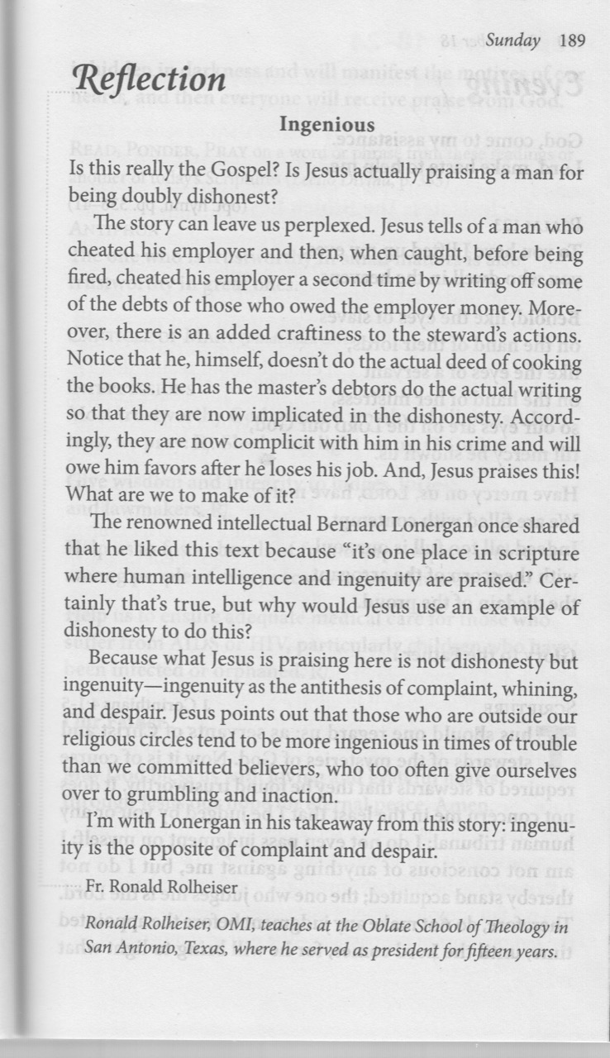
Feb 19 Elizabeth Whelan Fr. Prakash Lohale

This schedule, as always, is flexible. Planners, feel free to switch if you cannot do a liturgy on the scheduled date. Just be sure to tell the People Progress Reporter, so that we all know.
At the moment, all liturgies will be on Zoom.

For the Lenten and Easter liturgies, we will again request volunteer coordinators. Watch for emails, in early February, from the Lenten Convenor!

People Progress Schedule
January: Elizabeth Whelan
February: John MacMillan
March: Maryanne S-J and Roberto J
April: Mary Lou Jorgensen-Bacher

Announcements
- Egg cartons: Please continue to save your empty egg cartons for Elizabeth Stocking. She welcomes cartons and flats; you can deliver them to Elizabeth Whelan, and Elizabeth Stocking will pick them up. She thanks everyone who has contributed them, and has shared the recent 'collection' with two neighbouring farmers in need.

- Thank you, Brian Halferty for leading the music for many years, and for continuing to send the music 'program' and responses. We are grateful for all the musicians (too many to name) who, for decades, have contributed to our liturgies. As Brian mentioned in the current program, Sylvia Skrepichuk will lead the singing. Thank you, Sylvia!
January Birthdays: Happy Birthday to
8 Susan Morgan
9 Carolyn Scandiffio
15 Bernard Joseph McKeever
16 Evan Moncrieff
20 Carole Giangrande
21 Jack Murphy
25 Maryanne Stone-Jimenez
28 Jacqueline Vonbun
• • •

Re-printed weekly for reference:
Duties of liturgy planners for virtual masses:

Early in the week before the liturgy:
- Call or email the priest to confirm Sunday’s liturgy (contact info will be provided).
- Prepare or find a Reflection and send it to the People Progress reporter by Thursday. Please notify the People Progress reporter early in the week if you cannot do a Reflection.
- Select readers for the 1st and 2nd readings; check with Brian Halferty regarding the psalm.

On the Sunday of the virtual mass:
- Greet the group (Ask newcomers to introduce themselves)
- Give a brief introduction to the liturgy.
- Read your passage /be prepared to do a reading (if a volunteer is unable to log-in)
- Thank everyone who ‘attended’ and those who helped (at Announcements)

