People Progress
Sunday Community
Jan 22, 2023 3rd Sunday in Ordinary Time E. R. Whelan

Virtual Liturgy at 11 AM on Zoom.

Thank you, Fr. Prakash Lohale for celebrating with us.

Please read this note from Lee, planner of this Liturgy:

Fr. Prakash has asked me to look after the prayers of the faithful. I am therefore asking anyone who wants to offer a prayer of the faithful to prepare your prayer in advance. I will ask him to introduce the prayers, offer one myself, and ask him to close it off when there is no one else who wants to speak. Thanks!

Reflection:

So I am reading the readings for the nth time, trying to reflect.

In the gospel we have Jesus, recruiting followers who will soon be leaders, inviting humanity to a new vision that will be transformative. For some reason, as I was thinking (and thinking . . .) about this stuff, I found myself picturing Jesus in what I would call charismatic mode. A man who by his very presence is an invitation, pointing at something simultaneously familiar and also breathtaking, though not to say complicated, necessarily.

Then I got stuck on the word “repent." As usual, I found myself wondering “What does it look like when you do it? How can you tell?” Well, I am happy to say I had to look no further than YoutTube, where one can find a variety of lists of the steps to repentance. Whew! Capsule summary, “Acknowledge your sin, confess it, ask forgiveness turn away from it, make restitution.” (This is not meant to be disrespectful, by the way. There are good points here.) Well, okay, I can relate. I even stumbled into a couple of discussions regarding whether one can re-repent. (I certainly hope so). But there was something missing. Why was I not satisfied?

And then I remembered a conversation I had many years ago with Don Moncrieff, later my husband, but in the early days a seminarian volunteering at the Newman Centre. One day I brought to a group he was running the following question, raised by a gleefully unbelieving friend: “What is it with you Christians? You only do good things because it makes you feel good. It’s just another way of seeking pleasure.” Good question, I thought. Don thought for a moment and then said, “I would have said the good feeling comes from our experiencing being what and who we were meant to be.”

So what is the inner reality after repentance? There is more, I knew there was. And I found myself suddenly reflecting on an English language, twentieth century classic:.

“The night Max wore his wolf suit, and made mischief of one kind or another, his mother called him “Wild Thing” … and sent him off to bed without his supper. And Max went to the land of the wild things, and played with the wild things, but then stopped and refused their invitation to stay. And so “He stepped into his private boat, and sailed back over a year, and in and out of weeks, and through a day, and into the night of his own room, where he found his supper waiting for him. An it was still hot.” I think , and I know this is not a new thought, Jesus invitation to repentance is an invitation, as Don said so many years ago, to another homecoming, a journey back to our own room, where our supper will be waiting for us. And it will still be hot. Eventually.
Maurice Sendak: Where the Wind Things Are.”

Lee Piepgrass

Readings:
Jan 22: Isaiah 9:1-4 Psalm 27 I Cor 1:10-13, 17-18 Matthew 4:12-23
Jan 29: Zeph 2:3, 3:12-13 Psalm 146 I Cor 1: 26 -31 Matthew 5:1-12

The Liturgy schedule for 2023 until Lent.

Date Planner(s) Priest

Jan 22 Lee Piepgrass Fr. Prakash Lohale
Jan 29 Helena Burnstein & Martha Crean Fr. Paul McAuley
Feb 5 Lindsay & Bill Watson Fr. Jack Costello
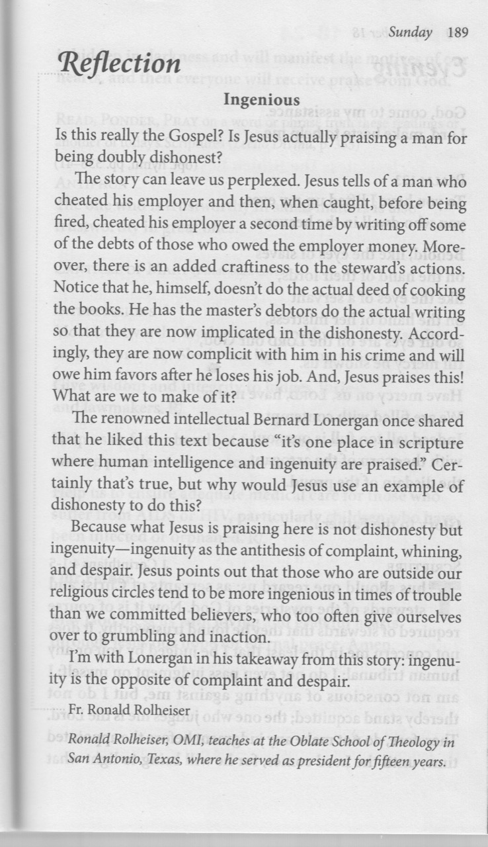
Feb 12 Maryanne S-J & Roberto J Fr. Paul McAuley
Feb 19 Elizabeth Whelan Fr. Prakash Lohale

This schedule, as always, is flexible. Planners, feel free to switch if you cannot do a liturgy on the scheduled date. Just be sure to tell the People Progress Reporter, so that we all know.
At the moment, all liturgies will be on Zoom.

For the Lenten and Easter liturgies, we will again request volunteer coordinators. Watch for emails, in early February, from the Lenten Convenor!

People Progress Schedule
January: Elizabeth Whelan
February: John MacMillan
March: Maryanne S-J and Roberto J
April: Mary Lou Jorgensen-Bacher

Announcements
Egg cartons: Please continue to save your empty egg cartons for Elizabeth Stocking. She welcomes cartons and flats; you can deliver them to Elizabeth Whelan, and Elizabeth Stocking will pick them up. She thanks everyone who has contributed them, and has shared the recent 'collection' with two neighbouring farmers in need.

January Birthdays: Happy Birthday to
8 Susan Morgan
9 Carolyn Scandiffio
15 Bernard Joseph McKeever
16 Evan Moncrieff
20 Carole Giangrande
21 Jack Murphy
25 Maryanne Stone-Jimenez
28 Jacqueline Vonbun

Re-printed weekly for reference:
Duties of liturgy planners for virtual masses:

Early in the week before the liturgy:
- Call or email the priest to confirm Sunday’s liturgy (contact info will be provided).
- Prepare or find a Reflection and send it to the People Progress reporter by Thursday. Please notify the People Progress reporter early in the week if you cannot do a Reflection.
- Select readers for the 1st and 2nd readings, and the Psalm.

On the Sunday of the virtual mass:
- Greet the group (Ask newcomers to introduce themselves)
- Give a brief introduction to the liturgy.
- Read your passage /be prepared to do a reading (if a volunteer is unable to log-in)
- Thank everyone who ‘attended’ and those who helped (at Announcements)

