People Progress
Sunday Community
Jan 29, 2023 4th Sunday in Ordinary Time E. R. Whelan

Virtual Liturgy at 11 AM on Zoom.

Thank you, Fr. Paul for celebrating with us.

Reflection: by Helena Burnstein

The story of the call of Samuel had a deep impact on my ten year old self. My grade five teacher in my Toronto public school was a minister’s wife, and she told us how Samuel heard a voice calling out to him at night, ‘Samuel, Samuel’
He finally told Eli, the temple priest, who said that the next time he heard the voice he should say, “Here I am Lord”. That story had such a strong impact on my 10 year old self that for months I lay in my bed at night straining to hear the voice of God calling me too but, to my chagrin, I heard nothing.

Two weeks ago I was sharing this story with a friend. That evening, I decided to look up the readings in anticipation of preparing a reflection. I could not believe the syncronicity of learning
that the theme throughout the readings is that of the CALL of God upon our lives.

In Zephaniah we learn of the ‘remnant of Israel’: “…a people humble and lowly who shall take refuge in the name of the Lord.

In the letter to the Corinthians we are told, “Consider your own calling, brothers and sisters. Not many of you were wise by human standards, not many were powerful….but God chose the weak…to shame the strong.”

Henri Nouwen uses today’s well-known gospel, the Sermon on the Mount, as a template for living the Christian life.

He tells us that in listening to the Voice of the Beloved, who calls us in Love, all the negative ‘voices’ lose their power to dissuade us from responding fully. (see utube video on the Call of the Beloved)

We see that Jesus’ relationship with God is his priority. Only then does he gather his disciples, thus building community and teaching them. Finally he ‘missions’ them to the world: “Notice the order, from Solitude to Community to Ministry.”.

I would invite us to reflect upon the story of our own call this week, for at some point — various times—we have said ‘yes’ and discerned the living out of our call— our mission to the world.

Readings:
Jan 29: Zeph 2:3, 3:12-13 Psalm 146 I Cor 1: 26 -31 Matthew 5:1-12
Feb 5: Isaiah 58:6-10 Psalm 112 I Cor 2: 1-5 Matthew 5: 13-15
The Liturgy schedule for 2023 until Lent.

Date Planner(s) Priest

Jan 22 Lee Piepgrass Fr. Prakash Lohale
Jan 29 Helena Burnstein & Martha Crean Fr. Paul McAuley
Feb 5 Lindsay & Bill Watson Fr. Jack Costello
Feb 12 Maryanne S-J & Roberto J Fr. Paul McAuley
Feb 19 Elizabeth Whelan Fr. Prakash Lohale

This schedule, as always, is flexible. Planners, feel free to switch if you cannot do a liturgy on the scheduled date. Just be sure to tell the People Progress Reporter, so that we all know.
At the moment, all liturgies will be on Zoom.

For the Lenten and Easter liturgies, we will again request volunteer coordinators. Watch for emails, in early February, from the Lenten Convenors Sharon McCarthy and Maria di Paolo!

People Progress Schedule
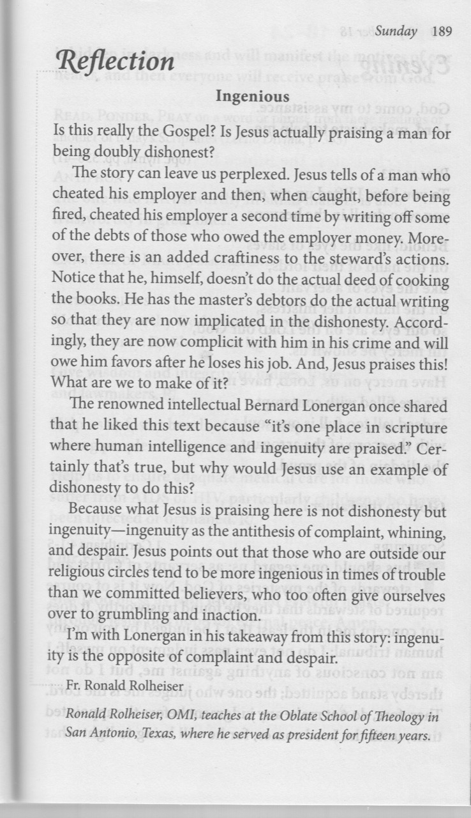
January: Elizabeth Whelan
February: John MacMillan
March: Maryanne S-J and Roberto J
April: Mary Lou Jorgensen-Bacher

Announcements:
Lent: Lent is fast approaching. As mentioned above, although there wil be no gathering of volunteers to choose a theme, we will still honour the S C tradition, and ask for volunteer planners/coordinators. Please consider our request and volunteer. Lenten liturgies are just like regular Sunday liturgies, and an outline is re-printed weekly in People Progress. We will also be asking for volunteers for the Passion/Palm Sunday and Easter Sunday liturgies, simplified for the Zoom format.
Thank you volunteers, and big thanks to Convenors, Sharon McCarthy, and Maria di Paolo!

Egg cartons: Please continue to save your empty egg cartons for Elizabeth Stocking. She welcomes cartons and flats; you can deliver them to Elizabeth Whelan, and Elizabeth Stocking will pick them up. She thanks everyone who has contributed them, and has shared the recent 'collection' with two neighbouring farmers in need.

January Birthdays: Happy Birthday to
8 Susan Morgan
9 Carolyn Scandiffio
15 Bernard Joseph McKeever
16 Evan Moncrieff
20 Carole Giangrande
21 Jack Murphy
25 Maryanne Stone-Jimenez
28 Jacqueline Vonbun

Re-printed weekly for reference:
Duties of liturgy planners for virtual masses:

Early in the week before the liturgy:
- Call or email the priest to confirm Sunday’s liturgy (contact info will be provided).
- Prepare or find a Reflection and send it to the People Progress reporter by Thursday. Please notify the People Progress reporter early in the week if you cannot do a Reflection.
- Select readers for the 1st and 2nd readings, and the Psalm.

On the Sunday of the virtual mass:
- Greet the group (Ask newcomers to introduce themselves)
- Give a brief introduction to the liturgy.
- Read your passage /be prepared to do a reading (if a volunteer is unable to log-in)
- Thank everyone who ‘attended’ and those who helped (at Announcements)

