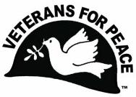
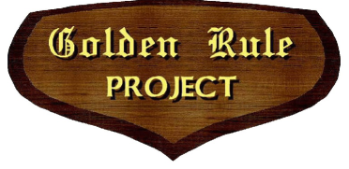
Veterans For Peace
Golden Rule Project
A National Project of Veterans For Peace
www.VFPGoldenRuleProject.org
vfpgoldenruleproject@gmail.com
P. O. Box 87
Samoa, California 95564-0087
- 992-6364

6 July 2023
Dear City of Toronto Mayor and City Council,
We would very much like to receive a “Proclamation of Welcome” from the City of Toronto, as follows:
Welcome Proclamation
The City of Toronto, Ontario
Hereby presents this certificate to Veterans For Peace and the Golden Rule peace boat
in Welcome to Toronto, Ontario
The Golden Rule in welcome to Toronto, Ontario
WHEREAS, in February 1958, four Quaker activists sailed the Golden Rule from California towards the Marshall Islands in an attempt to stop nuclear bomb tests in the Pacific and were arrested, prompting worldwide protests - which helped convince President John F. Kennedy to sign the Limited Nuclear Test Ban Treaty of 1963; and
WHEREAS, today, 15,000 nuclear warheads remain mostly under the control of Russia and the United States, and the United States has suspended its compliance with the Intermediate-Range Nuclear Forces Treaty and other nuclear arms limitation treaties and plans to spend nearly $2 Trillion on its nuclear arsenal; and
WHEREAS, the Golden Rule has been restored by Veterans For Peace and will be in Toronto from
24 to 27 July 2023 to: support the United Nations Treaty on the Prohibition of Nuclear Weapons, raise awareness about the environmental and human costs of military and nuclear activities, and support efforts to stop the possibility of nuclear war; now, therefore,
BE IT RESOLVED that the City of Toronto welcomes the Golden Rule to the City of Toronto and extends best wishes for a successful journey.
(Signatures)
Sincerely,
Helen Jaccard, Project Manager
Veterans For Peace Golden Rule Project

