Greetings friends. We invite you to join us at noon on October 4th, the opening day of the Synod in Rome, to pray and picnic together.
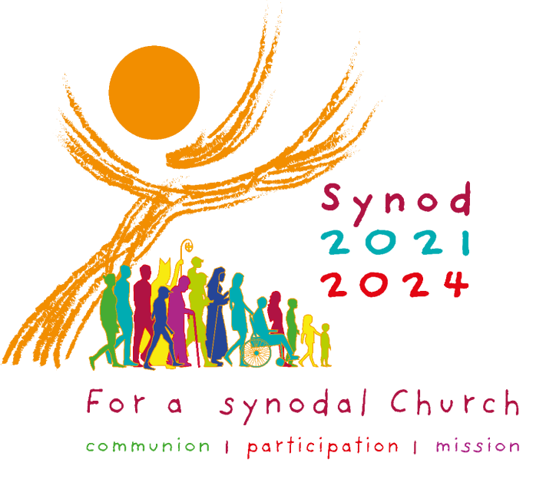
We are inspired to gather, by ten members of the Catholic Network for Women’s Equality (CNWE), who are traveling to Rome to join other groups of women from the U.S., Europe, Asia, Africa and Oceania. They will be part of an ‘extramural’ presence in Rome, supporting, encouraging, and questioning the ‘intramural’ delegates. One is Winnipegger Louise Dowhan.
We gather in Winnipeg, in solidarity with those in Rome, and hope/pray that this Synod may be a truly historic and transformative experience of God’s gracious presence and action among us.
For our prayer/picnic, we will meet at the burial site of George Bernard Cardinal Flahiff, who served as Bishop of the Archdiocese of Winnipeg from 1961-1982. Flahiff was an advocate for women’s full participation in the church.
WHO/WHERE/WHEN/WHAT/WHY
Who: all persons able to attend are welcome
Where: St Mary’s Cemetery – 520 Osborne St. N – enter through the gate, and go straight ahead towards the small “chapel like” building. We will be there.
When: Wednesday October 4, 2023 at 12.00 noon.
What: Bring a lunch! Bring a lawn chair. Bring an umbrella if it’s raining.
Why: To pray and picnic at Cardinal Flahiff’s grave, to re-member his gracious spirit, to embrace anew his vision of a church that welcomes the gifts of all.
For more, see: https://tinyurl.com/yc6c65w8
**If you let us know you are coming, we will send you a copy of the prayer for your phone – thus saving paper.**
Please feel free to share this invitation with others who may wish to join us.

