People Progress
Sunday Community
29 Oct 2023 30th Sunday in Ordinary Time Elizabeth Whelan

Welcome, Fr Ron!

Reflection: by John MacMillan
Inspired by an article by Carol J. Dempsey in the National Catholic Reporter

One of my small painful memories goes back to my teen years. I was delivering a food basket to a poor family in the slums of Montreal. The mother thanked me, and said to her young son, “See what beautiful teeth he has” – comparing me, pointedly, to her son, whose teeth were yellow. This is one more way young people learn they are “less than”, and I didn’t say a word.
People are still made, intentionally or not, to feel “less than”. The use of food banks in Canada, in March 2023, rose 78% from the same month in 2019 (just before the pandemic), and with the high inflation since the pandemic, the suffering is certain to have gone up. At the same time, the pandemic has created new billionaires among the western technology and pharmaceutical companies. Economic inequality is growing. The global power brokers continue to self-enrich.
Our first reading from the book of Exodus and the Gospel reading from the book of Matthew are clarion calls to right relationship. Despite all our advancement on so many levels throughout three millennia, human beings have yet to be able to live peacefully and justly with one another.
In the Exodus reading, focus is on those who are "other," harshly translated as "aliens" as if they were not part of humanity. In this narrative, the Israelites are reminded not to oppress the "other" among them because as Israelites, they were once a people living in a land not their own, migrants seeking asylum from severe famines and massive starvation. Were not our own families “other” at one time?
It's time for history to stop repeating itself by "othering." It's time to work for political, social, economic and environmental justice ever more arduously to abolish sexism, racism, ableism, colorism, ethnocentrism, Islamophobia, xenophobia, sexual orientation discrimination and the many more forms of discrimination that keep the “other” disenfranchised and on the margins.
The Holy One is part of the margins, lives on the margins, is embodied in the margins, is actively listening to and working for the margins with active divine compassion. The litmus test for people of any faith and spirituality today is the measure of how deep their active compassion is for the "other" among them which also includes non-human life, the new migrants of climate change. Active compassion entails changing oppressive structures, systems and ways of thinking.
The Gospel reading from the book of Matthew complements the first reading from Exodus. Increasingly, nations' governments are moving toward authoritarianism even among democracies. Fundamentalism and literalism are on the rise as people search for absolutes, law and order and certainty among sacred texts, constitutions and religious systems of thought.
Yet, the Gospel is clear. Law is not the means to the deep transformation needed in our world today; relationships create the pathways. For believers, the deeper the relationship one has with the Divine, the greater the flow of positive energy into self, an energy felt as love, that enlarges hearts and minds, compelling all to do the hard work of all-embracing justice without which no right relationship or transformation is possible.

Readings:
Today: Exodus 22.21-27 Psalm 18 I Thessalonians 1.5 -10 Matthew 22.34-40
Nov 5: Malachi 1.14-2.2, 8-10 Psalm 131 I Thess 2.7-9, 13 Matthew 23, 1-12

The Liturgy schedule:
Date Planner(s) Priest Oct 29 John & Mary MacMillan Fr. Ron MacDonell
Nov 5 Rita Shaughnessy Fr Jack Costello
Nov 12 Maryanne S-J & Roberto J Fr Jack Costello
Nov 19 Pat Smiley Fr. Prakash Lohale
This schedule, as always, is flexible. Planners, feel free to switch if you cannot do a liturgy on the scheduled date. Just be sure to tell the People Progress Reporter, so that we all know. Also, please notify PP early in the week (by the Tuesday before) if you cannot do a reflection.

People Progress Schedule
Oct: Elizabeth Whelan erwhelan@icloud.com
Nov: John MacMillan
Dec: Maryanne S-J and Roberto J
Jan: Mary Lou Jorgensen-Bacher
Please send your submissions to the People Progress Reporter by Thursday evening. People Progress welcomes new reporters. Thanks, Elizabeth.

Announcements:
• Advent and Christmas Liturgies: Volunteers needed! This year we will need coordinators for 3 Advent liturgies, as well as coordinator(s) for the Christmas Eve Liturgy. The 4th Sunday of Advent and Christmas Eve share Dec 24th this year, but (as in the past) we will only celebrate the Christmas Eve liturgy. The Advent Liturgies will all be online. More details soon....

• From Brian Halferty: (Updated) Sep 10th began our annual year of Sunday Community liturgies, which will continue right through to the end of June 2024.
NOTE that we are scheduling ONE SUNDAY PER MONTH as a Hybrid Liturgy, to be celebrated in-person at the school, Msgr Fraser Annex, but with a Zoom connection for those who are farther away or unable to attend in person.

• Egg cartons: Please continue to save your empty egg cartons for Elizabeth Stocking. She welcomes cartons and flats. You can deliver them to Elizabeth Whelan's house, and Elizabeth Stocking will pick them up. She thanks everyone who has contributed them.

• There is a flyer on page 5. Sylvia asked me to include it with the People Progress. I tried to reduce it, and to move it, without success. I don't know if
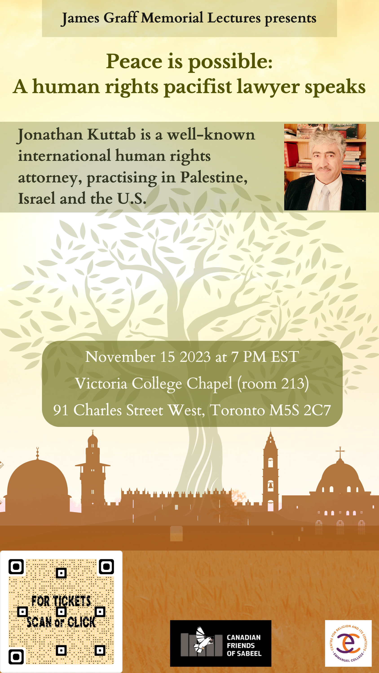
the scanning feature will work. If you plan to attend the lecture, please ask Sylvia about tickets, etc. sylviaskre@hotmail.com

October Birthdays. Happy Birthday to
1 John Corrado 7 Marjie Calla
2 Matthew Dunbar 18 Molly Sutkaitis
2 Ann Murphy 18 Roswita Zgraja
2 Barbara Podgorski 19 Tedd Dillon
5 Kate Jackson 19 Dwyer Sullivan
5 Sylvia Skrepichuk 23 Adam Branston

Re-printed weekly for reference:
Duties of liturgy planners for virtual masses:
Early in the week before the liturgy:
- Call or email the priest to confirm Sunday’s liturgy (contact info provided).
- Prepare or find a Reflection and send it to the People Progress reporter by Thursday. Please notify the People Progress reporter early in the week if you cannot do a Reflection.
- Select readers for the 1st and 2nd readings. Check with Sylvia Skrepichuk re: psalm
On the Sunday of the virtual mass:
- Greet the group (Ask newcomers to introduce themselves)
- Give a brief introduction to the liturgy.
- Read your passage or be prepared to do a reading (if a volunteer is unable to log-in)
- Thank everyone who helped and attended. (at announcements)

