People Progress
Sunday Community

May 26, 2024 Trinity Sunday Mary Lou Jorgensen-Bacher

Welcome, Fr Prakash!
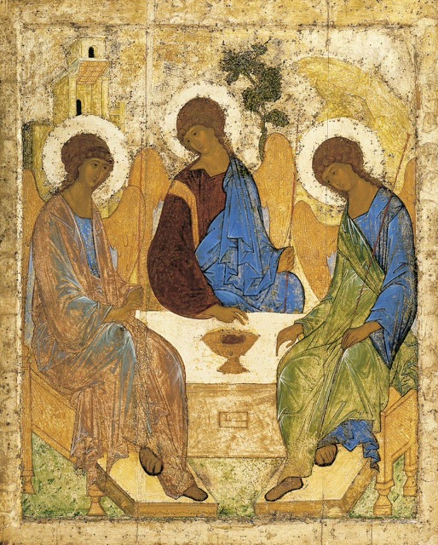
Reflection by Helena Burnstein Rublev Trinity ICON
﻿Offering HOSPITALITY is intrinsic to a life of faith. We are familiar with Dorothy Day and her ‘houses of hospitality’ and l’arche where people of different abilities are welcomed and form community. The role of the Postinik (hermit) at Madonna House is that of ‘radical availability’ to whomever knocks. Spiritual Direction, in which the director creates a welcoming space for the directee, also gives undivided attention which is a ‘ministry of presence’.
Rublev, the Russian monk in the fifteenth century, created the beloved ICON of the Holy Trinity that truly embodies Hospitality and symbolizes today’s feast of Trinity Sunday. As a ‘daughter’ of two traditions, it is especially close to my heart.
The Icon is based upon the encounter of the three tired travellers whom Abraham encountered while sitting outside his tent at Mamre. Abraham and Sarah welcomed them with refreshment and sustenance, preparing an incredible meal. They then told Sarah that she would conceive a son in her old age, presumably as a reward for their HOSPITALITY. There are differing interpretations of these visitors. The Jewish interpretation is that they were angelic messengers from God. In general, Christians view them as foreshadowing the Trinity. The Icon is known both as ‘The Hospitality of Abraham’ and ‘The Trinity’ (which is another story)!
The term PERICORESIS was coined in the third century to describe the HOSPITALITY of the Trinity. Daniel Shrick, a theologian explains it as “to make space’ or ‘to make room for’. Included is the’…concept of interpenetration in which the persons of the Trinity graciously make room for one another without in any way diminishing one another which is extended to include God’s relationship with creation. “The triune, God, therefore, is a source of all hospitality.”
I have always found this somewhat dry. I prefer the contemporary image of the Dance. Richard Rohr has written, ‘The Divine Dance’ as a reinterpretation of PERICORESIS which is compelling (and humorous): Bing Videos - Divine Dance: The Trinity and Your Transformation | Richard Rohr | Talks at Google
Readings
May 26 Dt 4:32-34, 39-40 Psalm 33 Rom 8:14-17 Mt 28:16-20
June 2 Ex 24:3-8 Psalm 116 Heb 9:11-15 Mk 14:12-16, 22-26

The Liturgy schedule:
Date Planner(s) Priest
May 26 Helena Burnstein Fr Prakash Lohale

June 2 Art Blomme Fr Ron MacDonnell
June 9 Elizabeth Whelan Fr Paul McAuley
June 16 Maryanne S-J & Roberto J. Fr. Prakash Lohale
June 23 Dwyer Sullivan Fr. Jack Costello
June 30 Rita & Brian Shaughnessy Fr Ron MacDonell
July 7 Sheila & Rob Barrett Fr Ron MacDonell
July 21 Lindsay & Bill Watson Fr Prakash Lohale
August 18 Dean Riley Fr Prakash Lohale

This schedule, as always, is flexible. Planners, feel free to switch if you cannot do
a liturgy on the scheduled date. Just be sure to tell the People Progress Reporter,
so that we all know.

People Progress Schedule
June: Elizabeth Whelan: erwhelan@icloud.com
Summer Sundays: John MacMillan: met191970@gmail.com

Please send your submissions to the People Progress Reporter by Thursday
evening. People Progress welcomes new reporters. Thanks!

2023-2024 Financial Report (John MacMillan)

September 1 up to and including May 19, 2024
Donations $4,134.69
Expenses
Priests $3,600.00 (36 Sundays)
Insurance $97.20
Room $174.78
Technology $133.08
Music Royalties $155.00
Christmas $200.00
Postage $32.12
Zoom $185.20
Total $4,577.38
Financial Assets
Bank $81.48
Cash $43.20
Total $124.68

We’re now at Pentecost, with 10 remaining Sundays before our return in September (counting for Sundays in the summer). Your help is needed once again!

Announcements

- During the summer, Elizabeth Whelan hopes to have two Saturday, potluck
gatherings for the Community, at her house. Dates to be determined, but likely late in July and August. All are welcome!

- Egg cartons: Please continue to save your egg cartons and flats for Elizabeth Stocking. You can bring them to Elizabeth’s Whelan’s home, and Elizabeth Stocking will pick them up. Thanks, from both Elizabeths!

Happy May Birthdays to:
1 Janette McCabe | 21 Simon Paul, Mary Sobanski, & Sara MacMillan
3 Gregory Wright | 24 Art Mayer & Daniel Mayer
5 Lee Piepgrass, Nathan Gillis, & Al Sobanski | 26 Mary Lou Jorgensen-Bacher & Brian Shaughnessy
8 John MacMillan | 27 Maria Pimentel
10 Tanya MacMillan | 30 Virginia Edman
20 Angela Blomme

Re-printed weekly for reference:

Duties of liturgy planners for virtual masses:
Early in the week before the liturgy:
Call or email the priest to confirm Sunday’s liturgy (contact info provided).
- Prepare or find a Reflection and send it to the People Progress reporter by Thursday. Please notify the People Progress reporter early in the week if you cannot do a Reflection.
- Select readers for the 1st and 2nd readings. Check with Sylvia Skrepichuk re: psalm

On the Sunday of the virtual mass:
- Greet the group (Ask newcomers to introduce themselves)
- Give a brief introduction to the liturgy.
- Read your passage or be prepared to do a reading (if a volunteer is unable to log-in)
- Thank everyone who helped and attended. (at announcements)

