People Progress
Sunday Community

September 29, 2024 26th Sunday in Ordinary Time Maryanne & Roberto

Welcome, Fr. Ron!

﻿Reflection: Jean Leahy

MESSAGE OF HIS HOLINESS POPE FRANCIS FOR THE 110th WORLD DAY OF MIGRANTS AND REFUGEES 2024 (Sunday, 29 September 2024)
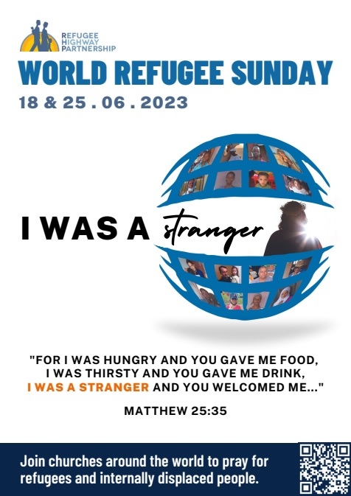
God walks with his people
Dear brothers and sisters!
Last 29 October marked the conclusion of the First Session of the XVI Ordinary General Assembly of the Synod of Bishops. This session allowed us to deepen our understanding of synodality as part of the Church’s fundamental vocation. “Synodality is mainly presented as a joint journey of the People of God and as a fruitful dialogue between the charisms and ministries at the service of the coming of the Kingdom” (Synthesis Report, Introduction).

Emphasizing the synodal dimension allows the Church to rediscover its itinerant nature, as the People of God journeying through history on pilgrimage, “migrating”, we could say, toward the Kingdom of Heaven (cf. Lumen Gentium, 49). The biblical narrative of Exodus, depicting the Israelites on their way to the promised land, naturally comes to mind: a long journey from slavery to freedom prefiguring the Church’s journey toward her final encounter with the Lord.

Likewise, it is possible to see in the migrants of our time, as in those of every age, a living image of God’s people on their way to the eternal homeland. Their journeys of hope remind us that “our citizenship is in heaven, and it is from there that we are expecting a Saviour, the Lord Jesus Christ” (Phil 3:20).

The images of the biblical exodus and of migrants share several similarities. Like the people of Israel in the time of Moses, migrants often flee from oppression, abuse, insecurity, discrimination, and lack of opportunities for development. Similar to the Jews in the desert, migrants encounter many obstacles in their path: they are tried by thirst and hunger; they are exhausted by toil and disease; they are tempted by despair.

Yet the fundamental reality of the Exodus, of every exodus, is that God precedes and accompanies his people and all his children in every time and place. God’s presence in the midst of the people is a certainty of salvation history: “The Lord your God goes with you; he will not fail you or forsake you” (Deut 31:6). For the people who came out of Egypt, this presence manifested itself in different forms: a pillar of cloud and fire showing and illuminating the way (cf. Ex 13:21), the meeting tent that protected the ark of the covenant, making God’s closeness tangible (cf. Ex 33:7), the pole with the bronze serpent assuring divine protection (cf. Nm 21:8-9), manna and water (cf. Ex 16-17) as God’s gifts to the hungry and thirsty people. The tent is a form of presence especially dear to the Lord. During David’s reign, God chose to dwell in a tent, not a temple, so that he could walk with his people, “from tent to tent and from dwelling to dwelling” (1 Chr 17:5).

Many migrants experience God as their traveling companion, guide and anchor of salvation. They entrust themselves to him before setting out and seek him in times of need. In him, they find consolation in moments of discouragement. Thanks to him, there are good Samaritans along the way. In prayer, they confide their hopes to him. How many Bibles, copies of the Gospels, prayer books and rosaries accompany migrants on their journeys across deserts, rivers, seas and the borders of every continent!
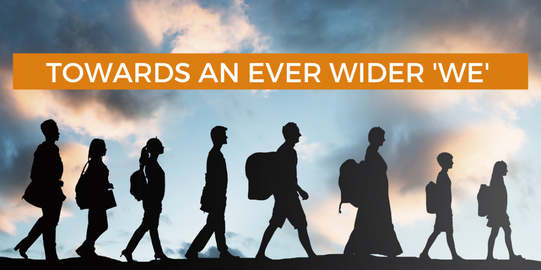
God not only walks with his people, but also within them, in the sense that he identifies himself with men and women on their journey through history, particularly with the least, the poor and the marginalized. In this we see an extension of the mystery of the Incarnation.

For this reason, the encounter with the migrant, as with every brother and sister in need, “is also an encounter with Christ. He himself said so. It is he who knocks on our door, hungry, thirsty, an outsider, naked, sick and imprisoned, asking to be met and assisted” (Homily, Mass with Participants in the “Free from Fear” Meeting, Sacrofano, 15 February 2019). The final judgment in Matthew 25 leaves no doubt: “I was a stranger and you welcomed me” (v. 35); and again “truly, I say to you, as you did it to one of the least of these brothers and sisters of mine, you did it to me” (v. 40). Every encounter along the way represents an opportunity to meet the Lord; it is an occasion charged with salvation, because Jesus is present in the sister or brother in need of our help. In this sense, the poor save us, because they enable us to encounter the face of the Lord (cf. Message for the Third World Day of the Poor, 17 November 2019).

Dear brothers and sisters, on this day dedicated to migrants and refugees, let us unite in prayer for all those who have had to leave their land in search of dignified living conditions. May we journey together with them, be “synodal” together, and entrust them, as well as the forthcoming Synod Assembly, “to the intercession of the Blessed Virgin Mary, a sign of sure hope and consolation to the faithful People of God as they continue their journey” (XVI Ordinary General Assembly Synthesis Report: Proceeding Along the Journey).

Prayer
God, Almighty Father,
we are your pilgrim Church
journeying towards the Kingdom of heaven.
We live in our homeland,
but as if we were foreigners.
Every foreign place is our home,
yet every native land is foreign to us.
Though we live on earth,
our true citizenship is in heaven.
Do not let us become possessive
of the portion of the world
you have given us as a temporary home.
Help us to keep walking,
together with our migrant brothers and sisters,
toward the eternal dwelling you have prepared for us.
Open our eyes and our hearts
so that every encounter with those in need
becomes an encounter with Jesus, your Son and our Lord.
Amen.
Rome, Saint John Lateran, 24 May 2024, Memorial of the Blessed Virgin Mary, Help of Christians
FRANCIS

The Liturgy schedule:
Date Planner(s) Priest
Sept 29 Jean Leahy Fr. Ron McDonnell

Oct 6 Maryanne and Roberto Fr. Jack Costello
Oct 13 Sheila and Robert Barrett Fr. Paul McAuley
Oct 20 Mary and John MacMillan Fr. Prakash Lohale
Oct 27 Lee Piepgrass Fr. Ron McDonnell

This schedule, as always, is flexible. Planners, feel free to switch if you cannot do
a liturgy on the scheduled date. Just be sure to tell the People Progress Reporter,
so that we all know.

People Progress Schedule
October: John MacMillan: met191970@gmail.com
November: Maryanne Stone-Jimenez: maryannestone.jimenez@gmail.com

Please send your submissions to the People Progress Reporter by Thursday
evening. People Progress welcomes new reporters. Thanks!

Announcements

Happy September Birthdays to:
1 Julia Gorman | 17 Matteo Calla & Michael Quintas
2 Tammy Chan | 21 Bill Watson
3 David Watson | 23 Denise Colterman-Fox
11 Sean Olsthoorn | 26 Mary MacMillan
16 Elizabeth Whelan †

Duties of liturgy planners for virtual masses:
Early in the week before the liturgy:
- Call or email the priest to confirm Sunday’s liturgy.
- Prepare or find a Reflection and send it to the People Progress reporter by Thursday.
- Select readers for the 1st and 2nd readings.
On the Sunday of the virtual mass:
- Greet the group (Ask newcomers to introduce themselves)
- Give a brief introduction to the liturgy.
- Be prepared to do a reading (if a volunteer is unable to log-in)
- Thank everyone who helped and attended. (at announcements)

