The Creation Mandala by Columban Fr. Vincent Busch
- The Birth of the Universe
4
5
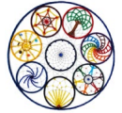
- The Birth of the Galaxies
- The Birth of the Solar System
- The Birth of Earth
6
3
- The Birth of Life
- The Birth of the Earth Community
- The Birth of Humans
7
2
- The Birth of the Ecological Age
1
8

