SAVE THE DATE
Watch for more information to come later

"For our health and the health of our Earth"
A Zoom with Diana Beresford-Kroeger
Saturday, April 26, 2024, 1 pm ET

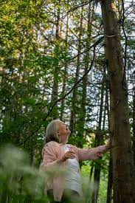 | “Diana is a world recognized author, medical biochemist, botanist and climate change visionary.  She has been working to preserve the environment since the early 1960s when she identified climate change as one of the most important challenges we would face in the modern age.  She discovered the importance of mother trees at the heart of the forest and she scientifically proved that trees are a living library of medicine that have a chemical language and communicate in a quantum world.  Diana’s legacy project is to clone and map the entire global forest. Creating a living library of the global forests will preserve the forests for generations to come.”

In her latest book, published September 2024, “Diana delivers a challenge to us all to dig deeper into the science of forests and the ways they will save us from climate breakdown—and then do our part to plant and protect them.”  https://dianaberesford-kroeger.com/ | 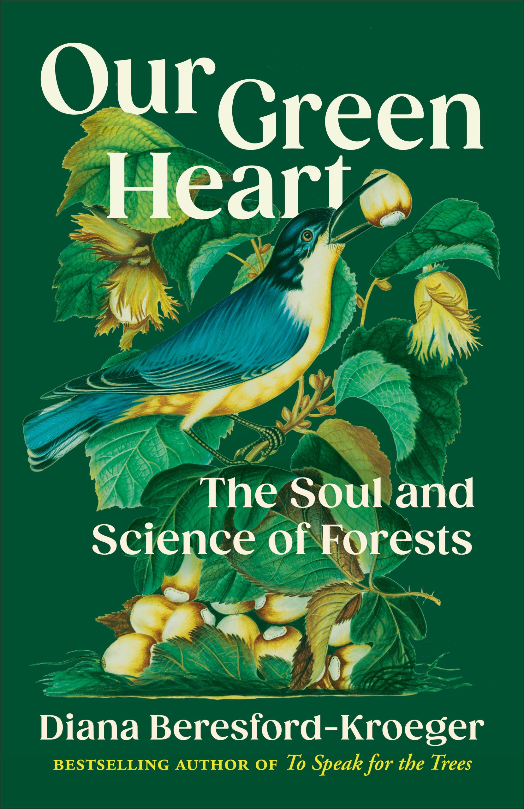

Sponsored by
 | 

