People Progress
Sunday Community

March 23, 2025 3rd Sunday of Lent Maryanne & Roberto

Link for Zoom Mass Sundays @11AM
Please copy the following link for the zoom Mass and paste in your browser or use Ctrl+Click:

https://us02web.zoom.us/j/83018087848?pwd=Yjh4VnV6QXE2MFRzbEZwWUpacmJ5UT09
Meeting ID: 830 1808 7848
Passcode: 333
One tap mobile
+15873281099,,83018087848#,,,,,,0#,,333# Canada
+16473744685,,83018087848#,,,,,,0#,,333# Canada
Dial by your location
+1 587 328 1099 Canada
+1 647 374 4685 Canada
+1 647 558 0588 Canada
+1 778 907 2071 Canada
+1 204 272 7920 Canada
+1 438 809 7799 Canada
Meeting ID: 830 1808 7848
Passcode: 333
Find your local number: https://us02web.zoom.us/u/kLVKQmbYj

Welcome Fr. Ron

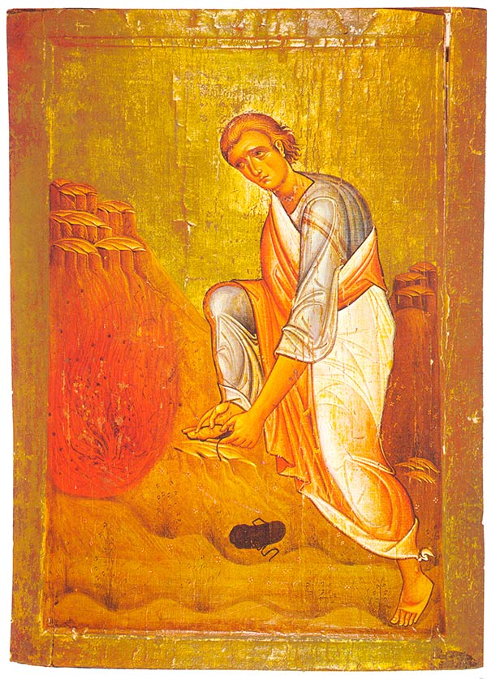
Reflection: Helena Burnstein

The well-known story of the call of Moses and the Burning Bush is the foundational story of scripture according to Richard Rohr. It is a favourite of mine which is why I volunteered today.
Many of you know that I went to Israel to join Neve Shalom—Wahat Al Salaam (Oasis of Peace), an interfaith community, as a sign to the world of peaceful co-existence. Alas, it was falling apart at the time I went although it eventually became a school for peace. I later wanted to be a tour guide to teach tourists about the land, but my mobility became compromised. Eventually I realized that my call was one of accompanying people spiritually on the ‘journey within’. It is this inner journey that is our focus during Lent when we are called to let go of those things that impede us from living our spiritual commitment authentically.
God tells Moses to take his shoes off because the place where he is standing, is holy ground.
Catherine Doherty, founder of Madonna House apostolate to the poor in Northern Ontario, (and a Russian baroness), wrote a beautiful reflection on the Burning Bush - divesting ourselves of all that would separate us from God, culminating in the removal of our shoes enabling the intimacy with God (and one another) that we crave.
“Somewhere along the road of life by the grace of God, my soul woke up and its hunger became a fire, a fire that consumed me.... I could not rest anywhere except in motion that led me to God. That is how I began, the journey inward – – that long, endless journey that every soul must undertake if she is to meet her God…. Yes, it is a strange journey that slowly makes me shed all the baggage I took for it – – before I knew that it was too heavy a load for this kind of journey.
Oh, I had forgotten my shoes, the heavy, comfortable shoes that shielded my feet from the cutting stones, from the sharp pebbles. I must unlace my shoes, the last covering of my body, the last stronghold of my non-surrender to God.
And now I am free, and my feet have huge wings that carry me across the sharp stones, and the knife edged pebbles, without harm. Now brambles and thorns that edge the path open up and point the other way. I am free and untrammeled by the hunger of my love for God on this journey inward.
I did not know it was going to be so easy now that I shed (my shoes). That hunger of mine is being so filled that I can feed others….But the price is (letting go), even unto discarding shoes.” Strannik 1971


Moses’ encounter with the Divine took place on Holy Ground.
Perhaps we need to expand our consciousness of Holy Ground to include all encounters done with dignity and respect. Indeed, we now understand that all of Creation is Holy.
In the words of the poet:
Earth’s crammed with Heaven,
And every common bush afire with God.
But only they who see take off their shoes.
The rest sit round it and pluck blackberries
and dab their natural faces unaware.
Elizabeth Barrett Browning

The Liturgy schedule:

Date Planner(s) Priest
March 23: 3rd Lent Helena Burnstein Fr. Ron MacDonell
March 30: 4th Lent Mary & John MacMillan Fr. Paul McAuley
April 6: 5th Lent Sheila & Rob Barrett Fr. Prakash Lohale
April 13: 6th Lent Maryanne & Roberto Fr. Paul McAuley
April 20: Easter Art Blomme Fr. Ron MacDonell

This schedule, as always, is flexible. Planners, feel free to switch if you cannot do a liturgy on the scheduled date. Just be sure to tell the People Progress Reporter, so that we all know.

Happy March birthdays:

March 3: Gwen Schauerte
March 8: Adrian Olsthoorn
March 10: Greg Gillis
March 11: Marianne Scandiffio
March 16: Francine Gillis
March 20: Rosemary Gray-Snelgrove
March 29: Jean Leahy CSJ

People Progress Schedule
March: Maryanne Stone-Jimenez: maryannestone.jimenez@gmail.com
April: John MacMillan: met191970@gmail.com

Please send your submissions to the People Progress Reporter by Thursday evening. People Progress welcomes new reporters. Thanks!

Duties of liturgy planners for virtual masses:
Early in the week before the liturgy:
- Call or email the priest to confirm Sunday’s liturgy.
- Prepare or find a Reflection and send it to the People Progress reporter by Thursday.
- Select readers for the 1st and 2nd readings.

On the Sunday of the virtual mass:
- Greet the group (Ask newcomers to introduce themselves)
- Give a brief introduction to liturgy
- Read the community response prayers or ask someone from the community to do the responses
- Be prepared to do a reading (if a volunteer is unable to log-in)
- Thank everyone who helped and attended (at announcements)

