People Progress
Sunday Community

March 30, 2025 4th Sunday of Lent Maryanne & Roberto

Link for Zoom Mass Sundays @11AM
Please copy the following link for the zoom Mass and paste in your browser or use Ctrl+Click:

https://us02web.zoom.us/j/83018087848?pwd=Yjh4VnV6QXE2MFRzbEZwWUpacmJ5UT09
Meeting ID: 830 1808 7848
Passcode: 333
One tap mobile
+15873281099,,83018087848#,,,,,,0#,,333# Canada
+16473744685,,83018087848#,,,,,,0#,,333# Canada
Dial by your location
+1 587 328 1099 Canada
+1 647 374 4685 Canada
+1 647 558 0588 Canada
+1 778 907 2071 Canada
+1 204 272 7920 Canada
+1 438 809 7799 Canada
Meeting ID: 830 1808 7848
Passcode: 333
Find your local number: https://us02web.zoom.us/u/kLVKQmbYj

Welcome Fr. Paul

Reflection: John MacMillan
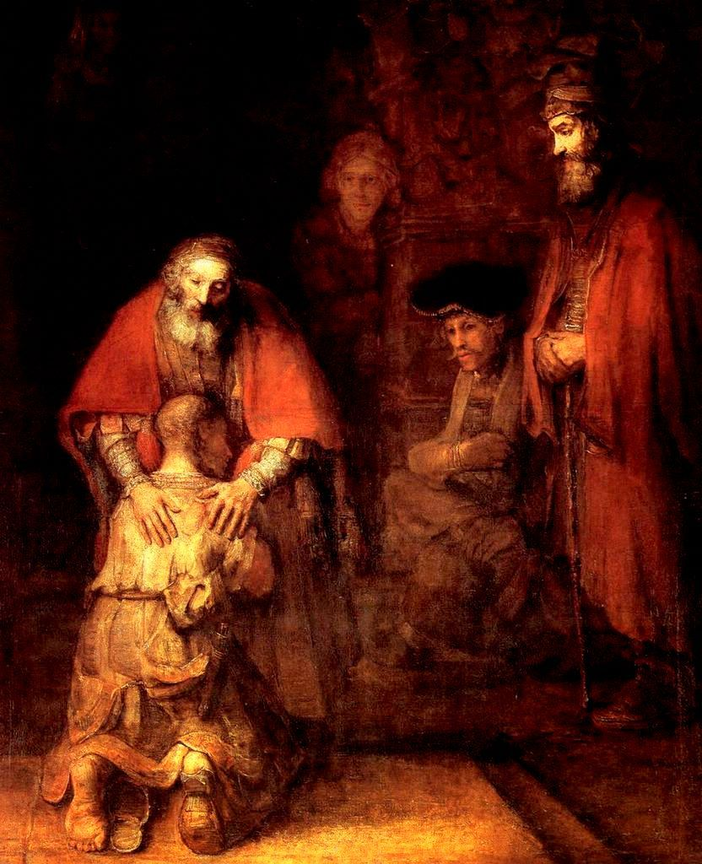
The prodigal son

Years ago, at the beginning of a seven-day retreat, my spiritual director had me meditate on Psalm 139, which begins: “For you formed my inward parts; you knitted me together in my mother's womb. I praise you, for I am fearfully and wonderfully made.”

The purpose was for me to feel known and loved by God through and through. But my reaction was quite different. I didn’t want to be that well known; it felt like an invasion of privacy! At a deep level I feared I was not who I seemed to be, and did not want this
to be found out. My struggle was to find out that God loves me anyway, with greater love than I could imagine.
The Return of the Prodigal Son; Rembrandt, 1669

In the marketplace, we are provided with incentives – and sometimes fear of “consequences”. By this dynamic when the errant son turns up, he is held to account. The older son expects this.

The prodigal son is a dramatic story of love and reconciliation. The younger son hopes to be treated as an employee, but dad is having none of it. He goes out to meet his son, rejoicing. The older son angrily rejects such unearned generosity. But the kingdom is not earned, it is given in love and beyond merit.

This Sunday we are invited to meditate on the abundance of God’s love. Our response, once we absorb it, is to love back, which leads us to become grateful and generous.

The media offers very little kindness. Let us direct more of our attention to the greater news that never fails to be relevant.

The Liturgy schedule:

Date Planner(s) Priest
March 30: 4th Lent Mary & John MacMillan Fr. Paul McAuley
April 6: 5th Lent Sheila & Rob Barrett Fr. Prakash Lohale
April 13: 6th Lent Maryanne & Roberto Fr. Paul McAuley
April 20: Easter Art Blomme Fr. Ron MacDonell

This schedule, as always, is flexible. Planners, feel free to switch if you cannot do a liturgy on the scheduled date. Just be sure to tell the People Progress Reporter, so that we all know.

Happy March birthdays:

March 3: Gwen Schauerte
March 8: Adrian Olsthoorn
March 10: Greg Gillis
March 11: Marianne Scandiffio
March 16: Francine Gillis
March 20: Rosemary Gray-Snelgrove
March 29: Jean Leahy CSJ

People Progress Schedule
March: Maryanne Stone-Jimenez: maryannestone.jimenez@gmail.com
April: John MacMillan: met191970@gmail.com

Please send your submissions to the People Progress Reporter by Thursday evening. People Progress welcomes new reporters. Thanks!

Duties of liturgy planners for virtual masses:
Early in the week before the liturgy:
- Call or email the priest to confirm Sunday’s liturgy.
- Prepare or find a Reflection and send it to the People Progress reporter by Thursday.
- Select readers for the 1st and 2nd readings.

On the Sunday of the virtual mass:
- Greet the group (Ask newcomers to introduce themselves)
- Give a brief introduction to liturgy
- Read the community response prayers or ask someone from the community to do the responses
- Be prepared to do a reading (if a volunteer is unable to log-in)
- Thank everyone who helped and attended (at announcements)

