Reflection:
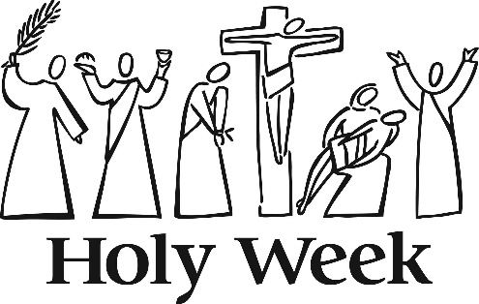
Last year on Palm Sunday, Liz Whelan shared an article written by Marcus Borg, Biblical scholar and theologian. The following is an abridged version of that same article.
“Let us seek to understand the story of Holy Week with its climax in the death and resurrection of Jesus within its first-century context of early Christianity and the New Testament.
As Mark (and Matthew and Luke) tells the story, the week is about a series of public provocative challenges to the authorities that lead to Jesus’ arrest and execution.
The week begins with Jesus’ arrival in Jerusalem at the beginning of the week of Passover. The city had an ambiguous, almost contradictory, status for Jews in the first century. On the one hand, it was the center of their world and devotion, the place of God’s presence in the temple, the destination of pilgrimage, the “Holy City.” Yet the city had become the center of religious collaboration with imperial power. The high priest and his circle of aristocratic families ruled the Jewish homeland on behalf of the Roman Empire. They owed their positions of power and wealth to appointment by the Roman governor, Pontius Pilate.
On Sunday, Palm Sunday, Jesus entered Jerusalem from the east in a procession riding on a donkey cheered by his followers. At the same time, a Roman imperial procession of troops and cavalry entered the city from the west, headed by Pilate. Their purpose was to reinforce the Roman garrison stationed near the temple for the season of Passover, when tens (hundreds?) of thousands of Jewish pilgrims filled the city.
Jesus’ mode of entry was symbolic, signifying that the kingdom of which he spoke was a kingdom of peace. According to the prophet Zechariah, the king entering Jerusalem on a donkey was to banish the weapons of war from the land and speak peace to the nations. The kingdom of Rome on the other hand was based on violence and the threat of violence.
On Monday, Jesus performed another provocative public demonstration. In the courtyard of the temple, he overturned tables where money was being changed into appropriate coinage for paying the temple tax. The temple had become the center of religious collaboration with imperial power, including imperial taxation.
On Tuesday, representatives of the authorities engage Jesus in a serious of verbal confrontations in the temple court, seeking to get him to say something that will discredit him with the crowd. They fail. On Wednesday, the authorities find a betrayer who will lead them to Jesus when he is not surrounded by the crowd.
On Thursday Jesus has a final meal with his followers and then, in the darkness of the Garden of Gethsemane, is arrested. On Friday, he is beaten, tortured, mocked as “king of the Jews,” and crucified. At mid-afternoon he dies, and his body is placed in a rich man’s tomb.
The mode of his execution is highly significant: in that world, crucifixion meant “executed by Rome.” A cross was always an imperial cross, reserved for those who defied imperial authority. Jesus was killed – he didn’t just die but was executed by the powers that ruled his world.
On Sunday, some of his women followers find his tomb empty and an angel declares to them: “He is not here – he is risen.” The empty tomb signifies that Jesus is not to be found in the land of the dead. As the angel asks the women, “Why do you seek the living among the dead?” For his followers, Easter meant that Jesus is a figure of the present, not just of the past.
The kingdom of God was at the center of Jesus’ message and activity according to Mark, Matthew and Luke. God’s kingdom is not about life after death, but life on earth. It is about this world transformed into a world of justice and peace. It was Jesus’ passion for the kingdom of God that led to his passion in the narrower sense of his suffering and death.
Within a historical framework, Good Friday and Easter have a second primary meaning within the context of the New Testament. Jesus’ death and resurrection, dying and rising, are a metaphor for the path of personal transformation.”

