People Progress
Sunday Community

April 27, 2025 Second Sunday of Easter John MacMillan

Link for Zoom Mass Sundays @11AM
Please copy the following link for the zoom Mass and paste in your browser or use Ctrl+Click:

https://us02web.zoom.us/j/83018087848?pwd=Yjh4VnV6QXE2MFRzbEZwWUpacmJ5UT09
Meeting ID: 830 1808 7848
Passcode: 333
One tap mobile
+15873281099,,83018087848#,,,,,,0#,,333# Canada
+16473744685,,83018087848#,,,,,,0#,,333# Canada
Dial by your location
+1 587 328 1099 Canada
+1 647 374 4685 Canada
+1 647 558 0588 Canada
+1 778 907 2071 Canada
+1 204 272 7920 Canada
+1 438 809 7799 Canada
Meeting ID: 830 1808 7848
Passcode: 333
Find your local number: https://us02web.zoom.us/u/kLVKQmbYj

Welcome Fr. Prakash

Wounds of Love: A Reflection for the Second Sunday of Easter
by Fr. Jim Caime, S.J. ~ Creighton University’s Director of Mission Engagement

“Blessed are those who have not seen and have believed.” (John 20:29)

I’m not surprised that Thomas doubted.

The other disciples had seen Jesus, touched his wounds, received the Holy Spirit. And yet—a week later—they’re still behind locked doors. If Easter had truly taken root, wouldn’t something have changed?

Thomas wasn’t being unreasonable. He just wanted what they had: a real encounter, something to hold onto. And really, who can blame him? Especially when the world still feels so heavy. When grief clings close and cruelty seems louder than compassion. Where’s the proof that Christ is risen?

Maybe that’s the deeper invitation of this Gospel. Resurrection isn’t proven by an empty tomb or a scarred body. It shows itself in transformed lives—disciples moving from fear to courage, from silence to witness. It's seen in people who forgive when it’s hard, who serve without being thanked, who love when it costs them something.

Belief isn’t just accepting a story. It’s about living it. And that kind of life leaves marks.

We bear the wounds of love: the ache of grief, the fatigue of caring, the heartbreak of watching others suffer. The daily effort to stay tender in a world that rewards hardness. The vulnerability of forgiving, of staying, of showing up again and again. These are not signs of failure. They’re signs that love has taken root in us.

And yet…some days, I am weary. I could just weep. The struggle isn’t over—it may just be beginning. But even then, Jesus comes. Not after we’ve figured it all out, but right in the middle of the mess. He comes through locked doors. He breathes peace. He shows his wounds. And he invites us to believe—not because it all makes sense, but because love still lives.

And if you find yourself doubting, grieving, barely holding on—you are not alone. The Risen Christ is near. In the tiredness. In the tears. In the quiet, stubborn hope that maybe—just maybe—love will rise again.
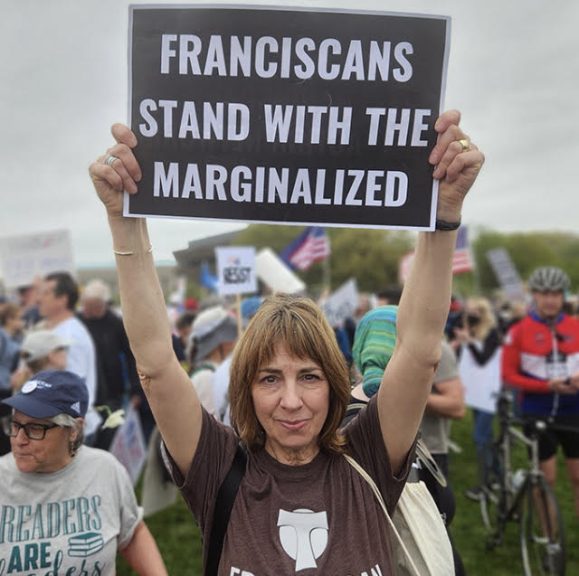

Reflection Submitted by Dean Riley
The Liturgy schedule:

Date Planner(s) Priest
April 27 Dean Fr. Prakash
May 4 Sharon Fr. Prakash
May 11 Lindsay and Bill Fr. Paul
May 18 Maryanne and Roberto Fr. Ron
May 25 Mary and John Fr. Prakash
June 1 Robert and Sheila Fr. Prakash
June 8 Dwyer Fr. Prakash
June 15 Fr. Ron
June 22 Fr. Paul

This schedule, as always, is flexible. Planners, feel free to switch if you cannot do a liturgy on the scheduled date. Just be sure to tell the People Progress Reporter, so that we all know.

Happy April birthdays:

April 4 Art Blomme
April 9 Kieran Gillis
April 20 David Walsh
April 20 Tony Shaughnessy
April 23 Brenda Holtkamp
April 27 Carol Radbord
April 30 Lindsay Watson
April 30 John Scandiffio
People Progress Schedule
April: John MacMillan: met191970@gmail.com
May: Maryanne Stone-Jimenez: maryannestone.jimenez@gmail.com

Please send your submissions to the People Progress Reporter by Thursday evening. People Progress welcomes new reporters. Thanks!

Duties of liturgy planners for virtual masses:
Early in the week before the liturgy:
- Call or email the priest to confirm Sunday’s liturgy.
- Prepare or find a Reflection and send it to the People Progress reporter by Thursday.
- Select readers for the 1st and 2nd readings.

On the Sunday of the virtual mass:
- Greet the group (Ask newcomers to introduce themselves)
- Give a brief introduction to liturgy
- Read the community response prayers or ask someone from the community to do the responses
- Be prepared to do a reading (if a volunteer is unable to log-in)
- Thank everyone who helped and attended (at announcements)

