People Progress
Sunday Community

November 9, 2025 Feast of the Dedication Maryanne & Roberto
of the Lateran Basilica in Rome

Link for Zoom Mass Sundays @11AM
Please copy the following link for the zoom Mass and paste in your browser or use Ctrl+Click:

https://us02web.zoom.us/j/83018087848?pwd=Yjh4VnV6QXE2MFRzbEZwWUpacmJ5UT09
Meeting ID: 830 1808 7848
Passcode: 333
One tap mobile
+15873281099,,83018087848#,,,,,,0#,,333# Canada
+16473744685,,83018087848#,,,,,,0#,,333# Canada
Dial by your location
+1 587 328 1099 Canada
+1 647 374 4685 Canada
+1 647 558 0588 Canada
+1 778 907 2071 Canada
+1 204 272 7920 Canada
+1 438 809 7799 Canada
Meeting ID: 830 1808 7848
Passcode: 333
Find your local number: https://us02web.zoom.us/u/kLVKQmbYj

Welcome Fr. Paul McAuley

Reflection: Helena Burnstein

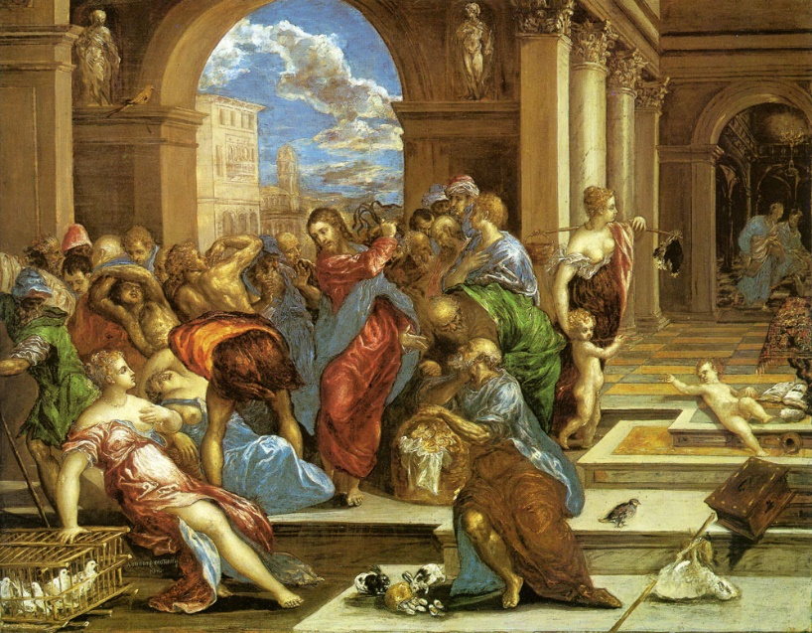
Many years ago, I was excited because Philip Berrigan, whom I admired for his protests against the Vietnam war such as pouring homemade napalm on draft files, was coming to my Catholic college to speak. (Canadians were well aware of the Draft and accepted many draft dodgers into Canada.).
The day before his arrival, the College refused to let him speak. Since I lived across the road, the venue was changed to my apartment where everyone crowded in. Sometime later. I spent a week with his community, Jonah House, in Baltimore.
Since that time, I have struggled within the framework of social justice (to which our community is committed), with ways of expressing solidarity with the poor and disenfranchised so that righteous anger can be expressed with creativity and hope.
Today’s gospel is the story of Jesus’ ‘cleansing of the Temple’ which I have always found troubling.
Even though it appears that Jesus’ anger was justified, and was certainly mitigated by the fact that no-one was physically wounded, how he chose to express that anger such as in the use of a whip he had made, turning over tables, etc. is concerning for me. (Even artwork depicting this event suggests that witnesses could have been traumatized.)
El Greco – Christ cleansing the temple

This incident was of such importance that it is in all three synoptic gospels as well as in John—the much later ‘theological’ gospel. Whereas it is at the beginning of the Synoptics after the wedding at Cana—the beginning of Jesus’ ministry, it occurs near the end of John, today’s gospel, which is considered as precipitating his arrest.
The traditional Christian interpretation regarding temple practices at the time may serve to justify Jesus’ reaction: That the money-changers cheated the pilgrims who were required to come to the temple for major festivals and exchange their money to local currency in order to purchase animals, birds for sacrifice. Also that people were required to buy them at higher prices at the temple which had turned it into a marketplace.
On the other hand, Amy-Jill Levine, the Jewish Biblical scholar who taught Christian seminarians, edited the Annotated Jewish New Testament, (and with whom Liz Whelan and I attended a conference), has provided insight that contradicts the general Christian exegesis of the temple situation in Jesus’ time. For example, she states that pilgrims could certainly not cope with carrying their own sacrifices when travelling. She challenges the criticism of the money changers. (To go into detail is beyond the scope of this reflection but is readily available on utube.)
What helps me in comprehending Jesus’ reaction in the temple is my familiarity with the prophets who so often struggled, for he is certainly in the line of the prophetic tradition.
In his new book on the prophets, ‘The Tears of Things’, Richard Rohr states that, “Unless we know the lineage, the exact genre, and the unique approach of the Hebrew prophets, we really can’t understand Jesus.”
I invite you to consider, ‘Who are our prophetic voices in our world for you today?’

The Liturgy schedule:

Date Planner(s) Priest
Nov 9 Helena Burnstein Fr. Paul McAuley
Nov 16 Sharon McCarthy Fr. Prakash Lohale
Nov 23 Dwyer Sullivan No Priest
Nov 30 Mary & John MacMillan No Priest

This schedule, as always, is flexible. Planners, feel free to switch if you cannot do a liturgy on the scheduled date. Just be sure to tell the People Progress Reporter, so that we all know.
People Progress Schedule
November: Maryanne Stone-Jimenez: maryannestone.jimenez@gmail.com
December: John MacMillan: met191970@gmail.com

Please send your submissions to the People Progress Reporter by Thursday evening. People Progress welcomes new reporters. Thanks!

Community Finances
From the beginning of September to November 2nd, inclusive, our community expenses have been:
Priests (for 7 Sundays) $ 875.00
Zoom $ 120.00
Postage $ 5.76
Total to date $1,000.76

Our financial situation is:
Bank $ 115.78
Cash $ 43.20
Total $ 158.98

Happy November Birthdays:

Nov 1: Larry Schmidt
Nov 17: Diane Gallagher †
Nov 18: Bob Anderson
Nov 20: Penny Dunbar
Nov 25: John Bacher
Nov 26: Michael Watson
Nove 28: Ron MacDonell, SFM

Duties of liturgy planners for virtual masses:
Early in the week before the liturgy:
- Call or email the priest to confirm Sunday’s liturgy.
- Prepare or find a Reflection and send it to the People Progress reporter by Thursday.
- Select readers for the 1st and 2nd readings.

On the Sunday of the virtual mass:
- Greet the group (Ask newcomers to introduce themselves)
- Give a brief introduction to liturgy
- Read the community response prayers or ask someone from the community to do the responses
- Be prepared to do a reading (if a volunteer is unable to log-in)
- Thank everyone who helped and attended (at announcements)

